26 May 2004 (URLs revised 4 Feb 2005)

A Decade of SST Satellite Data

by D.A. Griffin, C.E. Rathbone, G.P. Smith, K.D. Suber and P.J. Turner

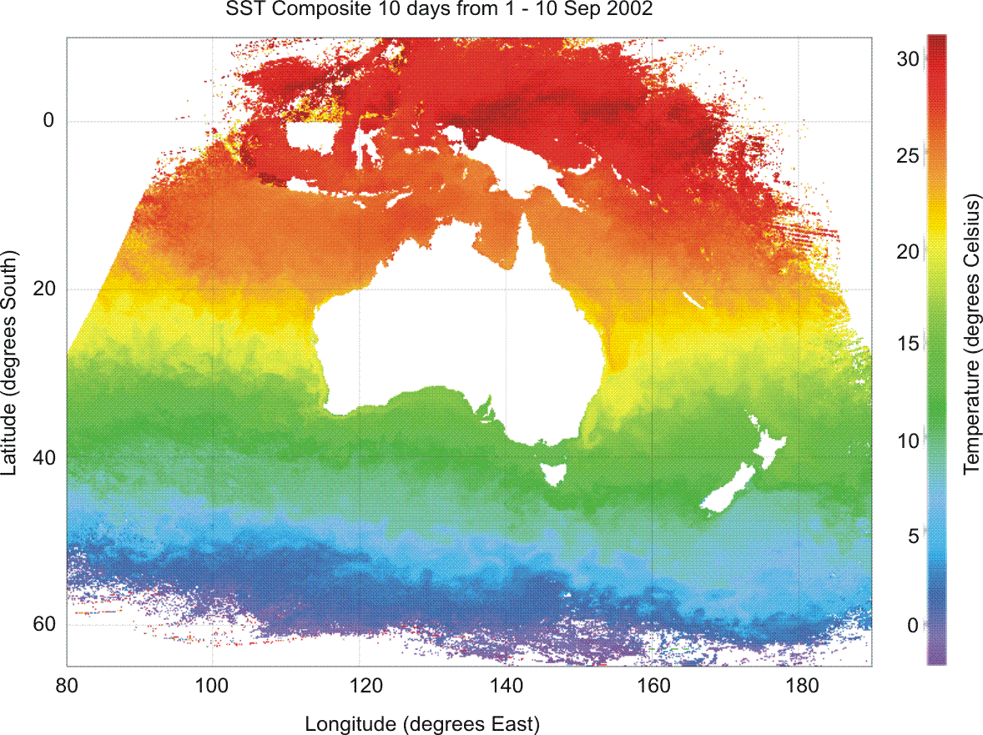

Final Report for the National Oceans Office
Contract NOOC2003/020



A Decade of SST Satellite Data
Summary
The aim of this project was to provide a fundamental ocean dataset of sea surface temperature (SST) for the Australasian region covering a 10 year period. The dataset has been derived from the analysis of NOAA environmental satellite AVHRR thermal imagery collected at a number of Australian satellite receiving stations including one at CSIRO Marine Research. The satellite instrument counts have been radiometrically corrected and mapped into a latitude and longitude grid. The dataset produced extends from 10N to 65S and 80E to 170W and includes both single-pass images at 1km resolution and composite images formed over intervals of 1, 3, 6, 10 and 15days. The composite images have been mapped onto an equal angle grid of 0.042 degrees of latitude (4km) and 0.036 degrees of longitude (2-4.5km). The dataset starts on 6 October 1993 and ends at 13 June 2003. The composite images have been made available on the internet and can be viewed as single gif images or fli animations at http://www.marine.csiro.au/remotesensing/oceancurrents/
or subsetted and downloaded from http://www.marine.csiro.au/remotesensing/oceancurrents/DIY.htm
in a number of formats. Both the single-pass and composite image datasets are registered in MarLIN, (http://www.marine.csiro.au/marlin/ then search for “ANMDG Pilot Project - A Decade of SST Satellite Data”) and the Australian Spatial Data Directory. The provision of these data will benefit the Australian community by enhancing our understanding of the Oceans and in particular improve our ability to forecast ocean state and the impact of climate change. In addition these allow a better understanding of ocean variability which allows sustainable management of marine industries.

Introduction
The Sea Surface Temperature (SST) data compiled in this resource cover the region 10N to 65S and 80E to 170W at a spatial resolution of 0.042 and 0.036 degrees respectively starting on the 6th October 1993 and ending in mid June 2003. The 1, 3 and 6 day composites are provided as daily maps, the 10 day composites every 2 days and 15 day composites every 6 days. The temperatures are given in degrees Celsius with an error of approximately one degree. A 10day SST composite of the full region is shown in Figure 1.

Figure 1. SST 10 day composite image for 5 September 2002

The coloured areas show the extent of satellite coverage from Australian reception sites.
Data can be viewed and downloaded from http://www.marine.csiro.au/remotesensing/oceancurrents/index.htm which includes a link to an implementation of the Live Access Server (LAS). LAS has been designed to provide datasets both graphically and digitally to the Ocean community over the internet via a GUI interface. Once the dataset is selected there are a series of access options. Data can be selected by stretching a rectangle over the area of interest or by entering the coordinates. There are options for selecting single images, image time series, slices and transects. Data can be viewed or downloaded as a netCDF file, text and some other miscellaneous formats.
There are some limitations on the data server and the user should be careful to select small areas when downloading long time series.

Data Description
The data are derived from top-of-atmosphere thermal radiances measured by the AVHRR instruments that have flown on successive NOAA TIROS Sun-synchronous polar-orbiting satellites. There are usually two or more of these satellites active and each satellite gives complete Earth coverage twice a day. The two satellites are usually placed in complimentary orbits giving a morning and afternoon daytime overpass and two night-time views. The maps of SST are created by overlaying the data from successive satellite observations. This overlaying or compositing of data helps to increase the accuracy of the result and also reduces the areas of the map where no data is available because of cloud contamination. The compositing is performed on 1, 3, 6, 10 and 15 day periods. The 1,3 and 6 day composites are available every day, the 10 day composite every second day and the 15 day composite every 6 days. The shorter compositing periods will show dynamic events on the sea surface but will contain more areas of missing data and more cloud contamination, while the longer compositing periods will represent an average of the ocean temperature but with much less missing data. The spatial error in the data is less than a kilometer. The accuracy of the temperature measure is limited to half a degree by the satellite instrument and then further degraded by atmospheric effects including undetected cloud, to the order of a degree. The compositing process is helpful in removing data affected by cloud or poor viewing conditions. The accuracy of the results is difficult to quantitatively access and is the subject of ongoing research. Figure 2 shows the average frequency of data as a function of position in the reference area. The higher the frequency of data the more likely the data will be present and the higher the accuracy of the result. More data points in the composite reduce the effect of undetected cloud or aerosol, but give a more averaged result.

Methodology
The Advanced Very High Resolution Radiometer (AVHRR) which flies on the NOAA TIROS-N series polar orbiting satellites has been operating since 1978. The data used in the SST datasets come from the AVHRR on NOAA 9, 11, 12, 14, 16 and 17. Data from these instruments has been received at a number of Australian stations and combined to cover the Australasian region (King, 2003). There are usually two satellites in orbit providing a morning and afternoon view and complimentary night passes. Figure 2 shows a coverage frequency map.

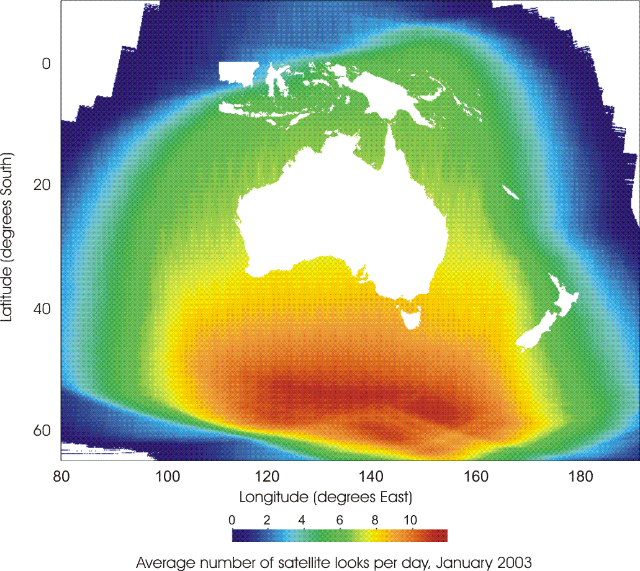

Figure 2. Satellite coverage for January 2003
Navigation
The initial data from the satellite is at a resolution of approximately 1 km at nadir and stretches in the satellite across track dimension to be of the order of 5 km at the edges. An accurate orbital predictor combined with a coast matching algorithm is used to determine the satellite orbit and attitude to allow geolocation of pixels to within a kilometre.

Radiometric Conversion
The AVHRR thermal bands used to derive SST are at 3.7, 11 and 12 μm (actual wavelengths vary slightly with each instrument). The instrument counts from these bands are converted to brightness temperature using standard procedures specified by NOAA (NOAA POD and KLM User Guides).

Cloud Detection
SST calculations can only be made where there is a clear view from the satellite to the ocean so areas affected by cloud cover must be excluded from the process. A cloud mask is generated for each satellite observation using the Saunders and Kriebel (1988) cloud detection algorithm. The algorithm applies a number of threshold tests to the data and creates a spatial cloud mask based on the pixels that fail any of the tests. The cloud detection algorithm can use the AVHRR visible channels for daylight passes, however, at night only the thermal channels are available. This means that the cloud detection process is less effective at night. Thin cloud is particularly difficult to detect at night and can depress the apparent surface emitted radiance. A rough estimate would be that 40% of thin cloud at night is not detected by the Saunders and Kriebel algorithm. This proportion will vary widely with each scene, and be dependent on time of day, season and location. Further work needs to be done to quantify and improve the effectiveness of the cloud detection process. The subsequent compositing process will, however, reject a high proportion of residual cloud affected data.

Sea Surface Temperature
The AVHRR thermal bands at 3.7, 11 and 12 μm are used to derive SST. The 3.7 μm band is affected by solar irradiance during the day and can only be used for SST calculation at night. SST algorithms try to exploit differences in the atmospheric transmissivity of two or more frequencies to adjust for the effect of the atmosphere and derive a surface temperature. The algorithms have a theoretical basis but are often empirically calibrated using bulk surface measurements. There are two SST algorithms used in this study. The first was developed by McMillin and Crosby (1984) and is applied to data from the NOAA 9 and 12 AVHRR data.
The SST are calculated using the expression

SST = a₀ + T₁₁ + a₁(T₁₁ – T₁₂)

where T₁₁ and T₁₂ are the 11 and 12 μm brightness temperatures and a₀ = -0.582, and a₁ = 2.702.

Subsequent data (NOAA 11, 14, 16 and 17) are analysed using the NOAA Nonlinear SST algorithm developed by NOAA (Sullivan et al, 1993) provides slightly more accurate results. There is a separate day and a night algorithm and a dependency on view angle included in this algorithm.

Night Algorithm

MCSST = c_{0,0} + c_{1,0}T₁₁ + c_{2,1}(T₃₇ – T₁₂) + c_{3,0}(secθ – 1)
SST = c_{0,1} + c_{1,1}T₁₁ + c_{2,1} MCSST(T₃₇ – T₁₂) + c_{3,1}(secθ – 1)

Day Algorithm

MCSST = c_{0,0} + c_{1,0}T₁₁ + (c_{2,0} + c_{3,0}(secθ – 1))( T₁₁ - T₁₂)
SST = c_{0,0} + c_{1,1}T₁₁ + (c_{2,1} MCSST+ c_{3,1}(secθ – 1))( T₁₁ - T₁₂)

where c are instrument dependent constants (see appendix) T₃₇ the 3.7 μm brightness temperature and θ the satellite scan angle. Some insight into the development of these algorithms can be found in a paper by Walton (1988).

Compositing
The compositing process applies a statistical selection procedure to a temporal and spatial sample of SST data to estimate the “best” temperature for that volume of data. The procedure reduces the spatial resolution by a factor of four and combines 1, 3, 6 , 10 and 15 days (compositing period) of data every 1, 1, 1, 2 and 6 days respectively. To achieve this result the compositing procedure aggregates the data into groups of 4 x 4 SST pixels x n, where n is the number of satellite views over the compositing period. The representative SST for each group is determined by taking the SST value at the 65th percentile of the cumulative frequency distribution within each group of data. The 65th percentile was chosen many years ago from a subjective assessment of a limited number of images of south-eastern Australian waters. Ongoing research will use objective techniques to reassess this methodology so that an improved set of composite images can be formed from the single-pass images produced by this project.

The overall effect of the compositing procedure is to reduce the effect of both cloud contamination and ‘warm-skin’ effect associated with periods of minimal wind-mixing. The longer compositing intervals yield images with fewer gaps and least contamination, at the expense of averaging-out useful detail in clear-sky regions. It is with this inherent trade-off in mind that we have produced composite images over a wide range of intervals to suit a potentially wide range of applications.

Conclusion
The datasets described here are unprecedented as a high-resolution, long-term time series of SST for the Australasian region. Future research will further improve the accuracy and streamline the delivery procedures. The datasets have been described including their derivation and limitations. The data are available online and are fundamental for the study of a wide variety of climate change and marine applications.

References

King, E. A. (2003) The Australian AVHRR Data Set at CSIRO/EOC: origins, Processes, Holdings and prospects. CSIRO CAR/EOC Report 2003/04, Canberra, Australia. 48 p
http://www.eoc.csiro.au/tech_reps/2003/tr2003_04.pdf

McMillin, L.M. and D.S. Crosby, 1984, Theory and Validation of the Multiple Window Sea Surface Temperature Technique, J. Geophy. Res., 89, C3, 3655-3661.

Walton, C.C., 1988, NonLinear Multichannel Algorithms for Estimating Sea Surface Temperature with AVHRR Satellite Data, J. Applied Meteorology, 27, 115-124.

Saunders, R.W., and Kriebel, K.T., 1998, An improved method for detecting clear sky and cloudy radiances from AVHRR data. International Journal of Remote Sensing, 9, 123-150.

Sullivan, J., C.Walton, J.Brown, and R.Evans, 1993, Nonlinearity corrections for the thermal infrared channels of the Advanced Very High Resolution Radiometer:Assessment and recommendations. NOAA Tech.Rep.NESDIS 69, 31pp. [ Available from the National Oceanic and Atmospheric Administration, U.S. Department of Commerce, Washington, DC 20233.]

Appendix

Constants for Non-Linear SST (c)

NOAA 11 | index | 0 | 1 | 2 | 3
night | 0 | -278.520 | 1.020151 | 2.319730 | 0.489092
night | 1 | -261.114 | 0.962191 | 0.083398 | 0.653750
day | 0 | -272.483 | 1.002243 | 1.021850 | 1.832606
day | 1 | -270.622 | 0.997019 | 0.035354 | 1.901725
NOAA 12
night | 0 | -263.006 | 0.963563 | 2.579211 | 0.242598
night | 1 | -236.667 | 0.876992 | 0.083132 | 0.349877
day | 0 | -271.971 | 1.000281 | 0.911173 | 1.710028
day | 1 | -260.854 | 0.963368 | 0.033139 | 1.731971
NOAA 14
night | 0 | -278.430 | 1.017342 | 2.139588 | 0.779706
night | 1 | -255.165 | 0.939813 | 0.076066 | 0.801458
day | 0 | -275.364 | 1.010037 | 0.920822 | 1.760411
day | 1 | -266.186 | 0.980064 | 0.031889 | 1.817861
NOAA 16
night | 0 | -268.5173 | 0.9819 | 2.2314 | 0.5580
night | 1 | -250.6939 | 0.9233 | 0.0755 | 0.8015
day | 0 | -271.5134 | 0.9955 | 0.9586 | 1.4296
day | 1 | -261.4709 | 0.9627 | 0.0327 | 1.5653
NOAA 17
night | 0 | -271.1821 | 0.9924 | 2.5475 | 1.0100
night | 1 | -252.4396 | 0.9304 | 0.0870 | 1.0076
day | 0 | -275.2498 | 1.0107 | 0.9697 | 1.9222
day | 1 | -262.5276 | 0.9684 | 0.0334 | 1.9245

