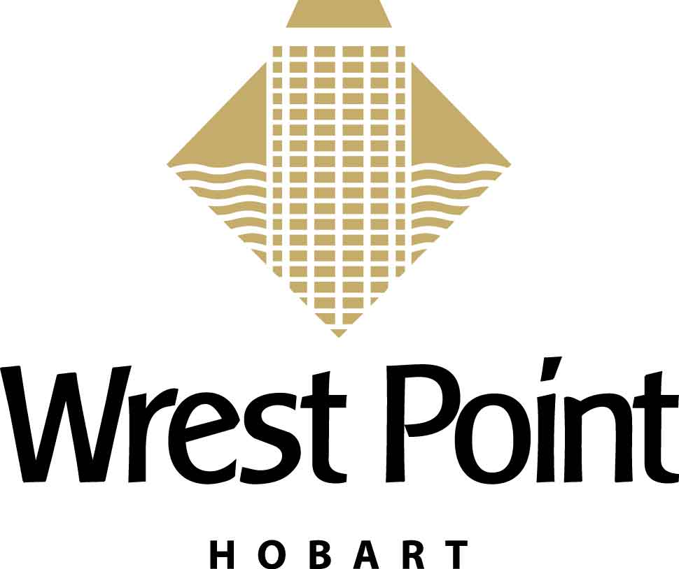

WREST POINT HOTEL
ACCOMMODATION BOOKING FORM

Please fax this form directly to the Federal Group Reservations on Fax: 03 6225 3909
For enquiries, please phone Group Reservations on 1800 139 760 or email: groups@federalgroup.com.au

Bio-Logging IV International Conference - Ref: 282658

Name
Check In: Check Out:
Room type | Single / Twin / Double  Room only rate per room per night
Tower – Run of House | $196.00
Water Edge | $161.00
Mountain Side | $133.00

Requested Room Type (please circle): Tower - Run of house Water Edge Mountain Side
Total number of guests per room: Adults: ____
Please indicate: Single Twin Double
Name:
Address:
Postcode
Phone: Fax:
Email:
Expected arrival at hotel:__________am/pm
Minimum one night deposit required for all bookings:
Mastercard Visa American Express Diners Club Cheque
Cardholder’s name:
Card number:
Expiry date: Amount to be paid $
Signature: Date:
Cancellation fees apply for cancellations received with in 24 hours of check-in. Please speak with Group Reservations for more information.
For Federal Group Use only:
Booking Confirmation Number:
If guest does not receive a fax or email back with a confirmation number,
then room has not been booked.

