Optimal sampling strategies for oceanic applications

Dr Peter R. Oke
CSIRO Marine and Atmospheric Research and Wealth from Oceans Flagship Program
GPO Box 1538 Hobart TAS 7001 Australia
phone: (+61 3) 6232-5387 fax: (+61 3) 6232-5123 email: peter.oke@csiro.au

Award Number: N000014-07-11054,
including partial support from ONR Global's Naval International
Cooperative Opportunities Program (NICOP)
http://www.cmar.csiro.au/staff/oke/onr.htm

LONG-TERM GOALS

The long-term goals of this project include the development of objective and efficient tools for designing optimal sampling strategies for oceanic applications; and to develop and apply practical methods for ocean data assimilation.

OBJECTIVES

The immediate scientific objective of this research is to develop an ensemble-based tool for the objective design of an optimal sampling strategy for long-term monitoring programs. Subsequently, this project aims to apply this tool for adaptive sampling to reduce errors in data assimilating predictive models.

APPROACH

We have developed a method for optimal array design and applied it to a suite of applications, including the design of a surface mooring array in the tropical Indian Ocean (Sakov and Oke 2007). The method builds on the work of Bishop et al. (2001), using data assimilation theory to determine the observation locations that best constrain a data assimilating ocean model. The method seeks to identify the set of observations that minimize the analysis error variance of a predefined variable or quantity. We assume that the purpose of making a series of observations is to initialize a data assimilating ocean model. At present, we assume that the data assimilation scheme used to assimilate the observations is ensemble optimal interpolation (EnOI; e.g., Oke et al. 2006). Under this project, we propose to modify our approach, to accommodate other data assimilation methods (e.g., Ensemble Kalman Filter, EnKF).

The method we describe here can be generalized to employ either an ensemble of model states from a long model run, or from an ensemble of model runs; or time series of observations (e.g., gridded sea-level or sea surface temperature).

An important consideration in the development of optimal sampling strategies is an understanding of the impact of different observation types on a data assimilating predictive model. Under this and a related project (Bluelink) we have explored this question (see Oke and Schiller 2007, GRL).

Key individuals:

Dr. Peter Oke is the P.I. on this project and leads the data assimilation group at CSIRO Marine and Atmospheric Research (CMAR).

Dr. Pavel Sakov is a research scientist from CMAR. Dr. Sakov is an expert in ensemble data assimilation and is undertaking most of the hand-on research under this project.

The US-based researchers involved in this project are Dr. H. Ngodock and Dr. G. Jacobs. All have a long history of research in the area of ocean data assimilation.

WORK COMPLETED

We have applied an ensemble-based method for optimal array design to several applications, including the design of a surface mooring array in the tropical Indian Ocean (Sakov and Oke 2007). In addition to this study, we have extended the method for multivariate and three-dimensional applications.

We have conducted a series of observing system experiments (OSEs) to investigate the relative importance of different observation types (Argo, altimeter and SST data) for constraining an eddy resolving ocean model.

RESULTS

Objective array design:

We have developed a simple, versatile, computationally efficient ensemble-based method for objectively designing an observation array. The versatility of the method is demonstrated by Sakov and Oke (2007) through a series of applications to the tropical Indian Ocean (TIO). The first application uses model-generated fields of high-pass filtered mixed layer depth to design an array to monitor intraseasonal variability. The second uses gridded observations of sea-level anomaly to design an array to monitor intraseasonal to interannual variability. For both applications, the objectively designed arrays are compared to an array that will soon be implemented under the auspices of the CLIVAR-GOOS Indian Ocean Panel (CG-IOP). We conclude that the CG-IOP array produces results that compare well to the objectively designed arrays for intraseasonal variability, and that observations to the east and north-east of the TIO and south of India are most important for resolving intraseasonal variability. We also find that observations near 9ºS, where seasonal Rossby waves dominate, are important for observing seasonal to interannual variability. The described method for objective array design can be applied to a wide range of geophysical applications where time series of gridded modelled or observed fields are available.

Observing System Experiments:

We wish to quantify the relative importance of different observation types, namely Argo, altimeter and SST data, for constraining an eddy resolving ocean reanalysis. We use the Bluelink forecast system (see related projects, below; and Oke et al. 2005; 2007) to conduct a series of OSEs to address this. Results from this study are presented by Oke and Schiller (2007). A qualitative assessment of the impact of with-holding each data type in the Tasman Sea is shown in Figure 1. The circulation in the Tasman Sea is dominated by the East Australian Current (EAC) and a rich field of mesoscale eddies. In Figure 1, we show 6-day composite SST from AVHRR measurements (first column) that are not assimilated, and 6-day averaged SST for each OSE (columns 2-6). The vector paths plotted in Figure 4 show Lagrangian trajectories over each 6-day period, computed from the time-dependent reanalysed surface currents. Fields are shown for each OSE in mid-January, mid-February and mid-March 2006. The fields in Figure 4 show that when SST is assimilated, the reanalysed SST is very similar to the observed SST. By contrast, when SST is not assimilated the reanalysed SST differs significantly from observations. These differences are reduced in ALTIM+Argo, when altimetry and Argo data are assimilated, compared to NONE, when no data are assimilated. It is clear from Figure 4 that the mesoscale circulation is qualitatively similar for each OSE when altimetry is assimilated, but is quite different otherwise. For example, the position of the Tasman front in January and February, denoted by the separation of the EAC from the coast around 32ºS, is very similar in the OSEs that assimilate altimetry. Also note the robustness of the anti-cyclonic circulation around 152ºE and 37ºS in February and March; and the coastal meander near 29ºS in February that is evident in the observations and the OSEs that assimilate altimetry. These considerations lead us to the conclusion that altimetry is required for mesoscale circulation to be resolved.

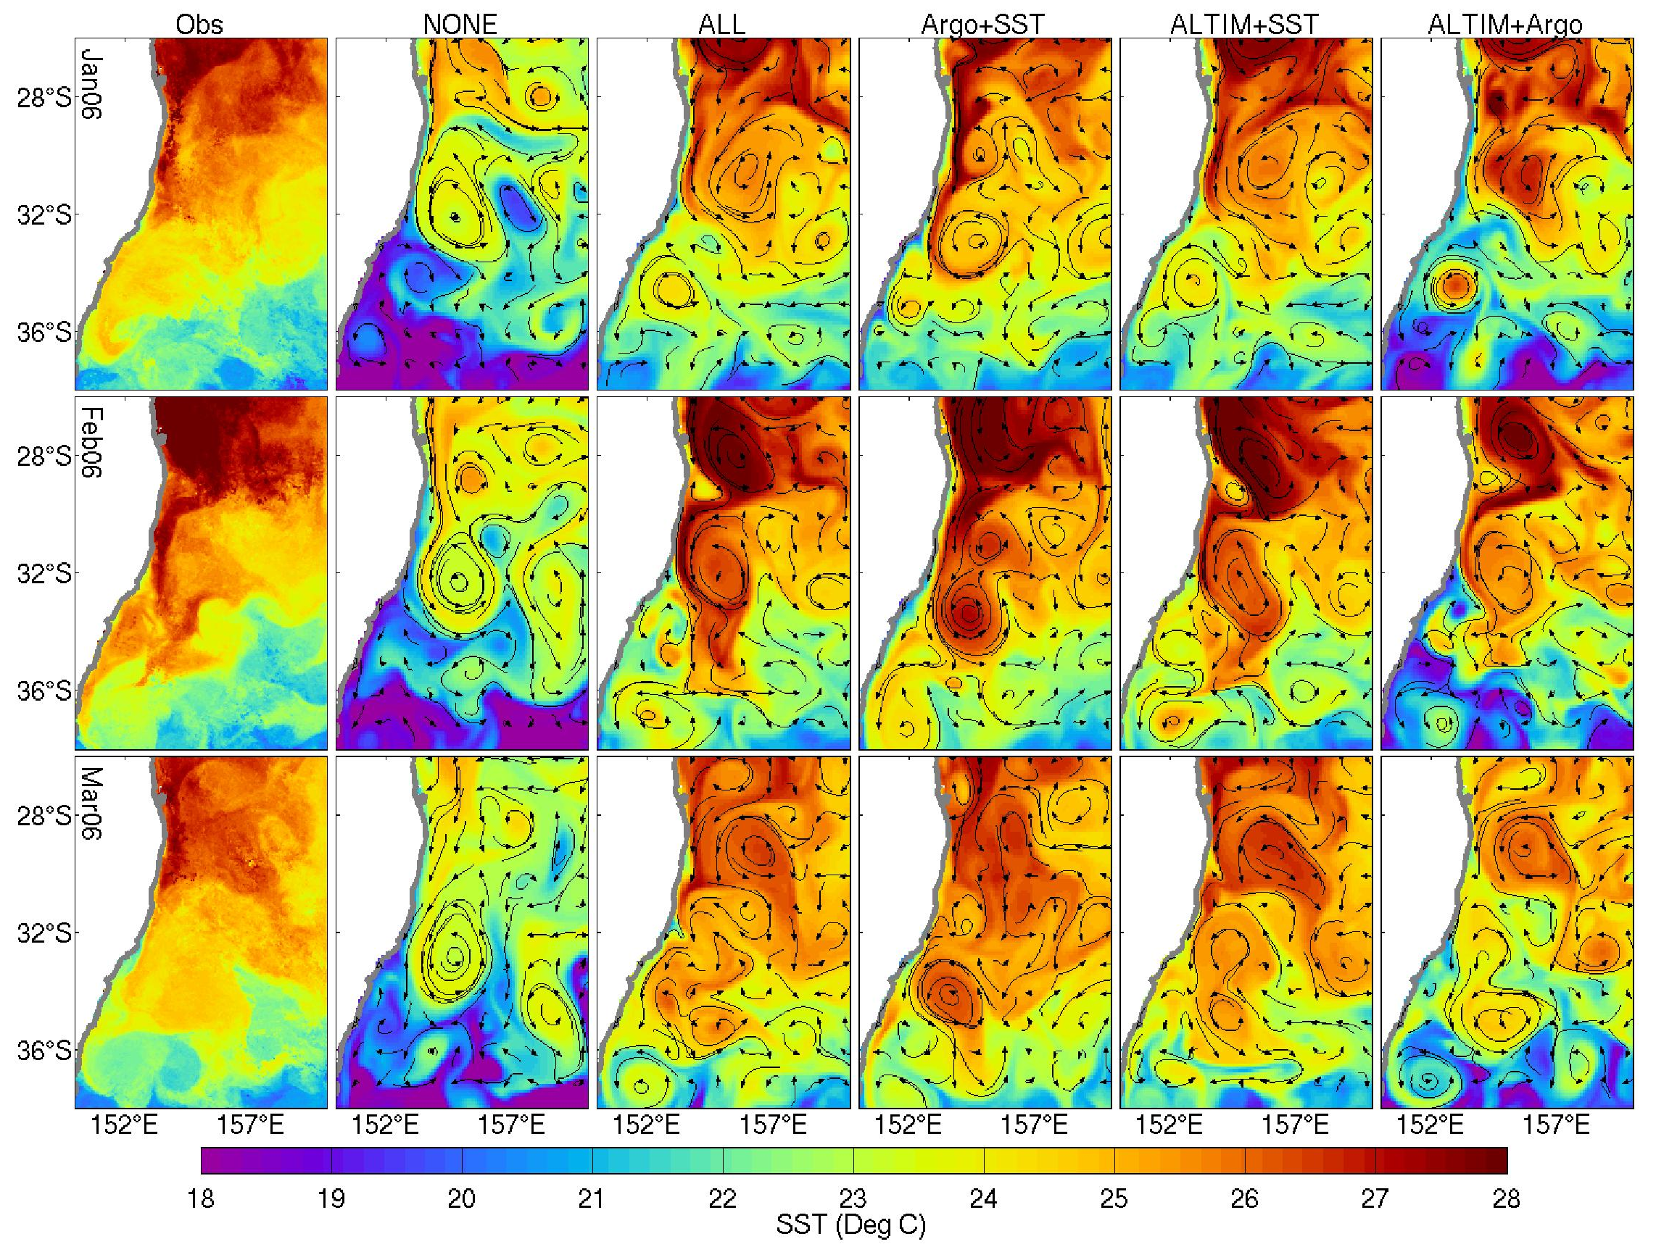
Figure 1: Observed SST from 6-day composite AVHRR (left column); and 5-day
averaged SST with virtual drifter paths overlayed for each OSE (columns 2-6) in the
Tasman Sea for mid-January (top), mid-February (middle) and mid-March (bottom) of
2006 (adapted from Oke and Schiller 2007). These results demonstrate the importance of altimeter data for constraining the mesoscale ocean circulation; and the importance of SST for constraining the details of the mesoscale SST variability.
[Figure showing comparisons between observed SST and SST from each OSE]
IMPACT/APPLICATIONS

The tools for objective array designed that have been developed under this project are potentially very powerful. Given a time series, or model ensemble, of oceanic fields for some region, these tools enable us to efficiently design an observation array for that region. Our experiments indicate that the most critical aspect of any application is formulating the cost function. That is, in determining exactly what it is that we wish to monitor. For example, an ``optimal’’ array for monitoring intraseasonal mixed layer depth is likely to be very different from an ``optimal’’ array for monitoring interannual variability. This is demonstrated by Sakov and Oke (2007).

The results from the OSEs presented by Oke and Schiller (2007) provide an important assessment of the performance of the Global Ocean Observing System (GOOS) for a data-assimilating, eddy-resolving ocean forecast system. Such information is essential for planning investment in the maintenance and development of the GOOS.

RELATED PROJECTS

Bluelink, is a partnership between CSIRO, the Bureau of Meteorology and the Royal Australian Navy. Many of the research activities undertaken in Bluelink have strong synergies for the project that is the subject of this annual report. The main objective of Bluelink is the development and application of an ocean forecast system for the mesoscale circulation around Australia. This system is comprised of a global configuration of the Modular Ocean Model (version 4.0d; Griffies et al. 2004), with 1/10º resolution around Australia, and the Bluelink Ocean Data Assimilation System (BODAS; Oke et al. 2005). Briefly, BODAS is an EnOI-based system that can assimilate observations of SLA from satellite altimetry or coastal tide gauge stations, satellite SST, and in situ temperature and salinity from Argo etc. The details of BODAS are presented by Oke et al. (2007), along with a comprehensive assessment of the latest Bluelink ReANalysis (BRAN) experiment. Oke et al. (2007) show that that reanalysed fields are typically within 6-12 cm of withheld altimetric observations, within 0.5-0.9º of observed sea-surface temperature and within 4-7 cm of observed coastal sea-level. Comparisons with Argo profiles and surface drifting buoys show that BRAN fields are within 1º of observed sub-surface temperature, within 0.15 psu of observed sub-surface salinity and within 0.2 m/s of near-surface currents. An example of the comparisons presented by Oke et al. (2007) is shown in Figure 2, where observed and reanalysed SST are compared off Western Australia during 2004. The observations used in these comparisons were not assimilated into BRAN. The agreement between these fields demonstrates that the Bluelink system can realistically represent the mesoscale ocean circulation. Oke et al. (2007) present a more comprehensive assessment of this system, including an assessment of the short-range forecast skill of the Bluelink system for SST and SLA.

The Bluelink Ocean Forecasting System became operational at the Bureau of Meteorology in August 2007 (www.bom.gov.au/oceanography/forecasts/). Subsequently, this system has produced two 7-day forecasts each week.

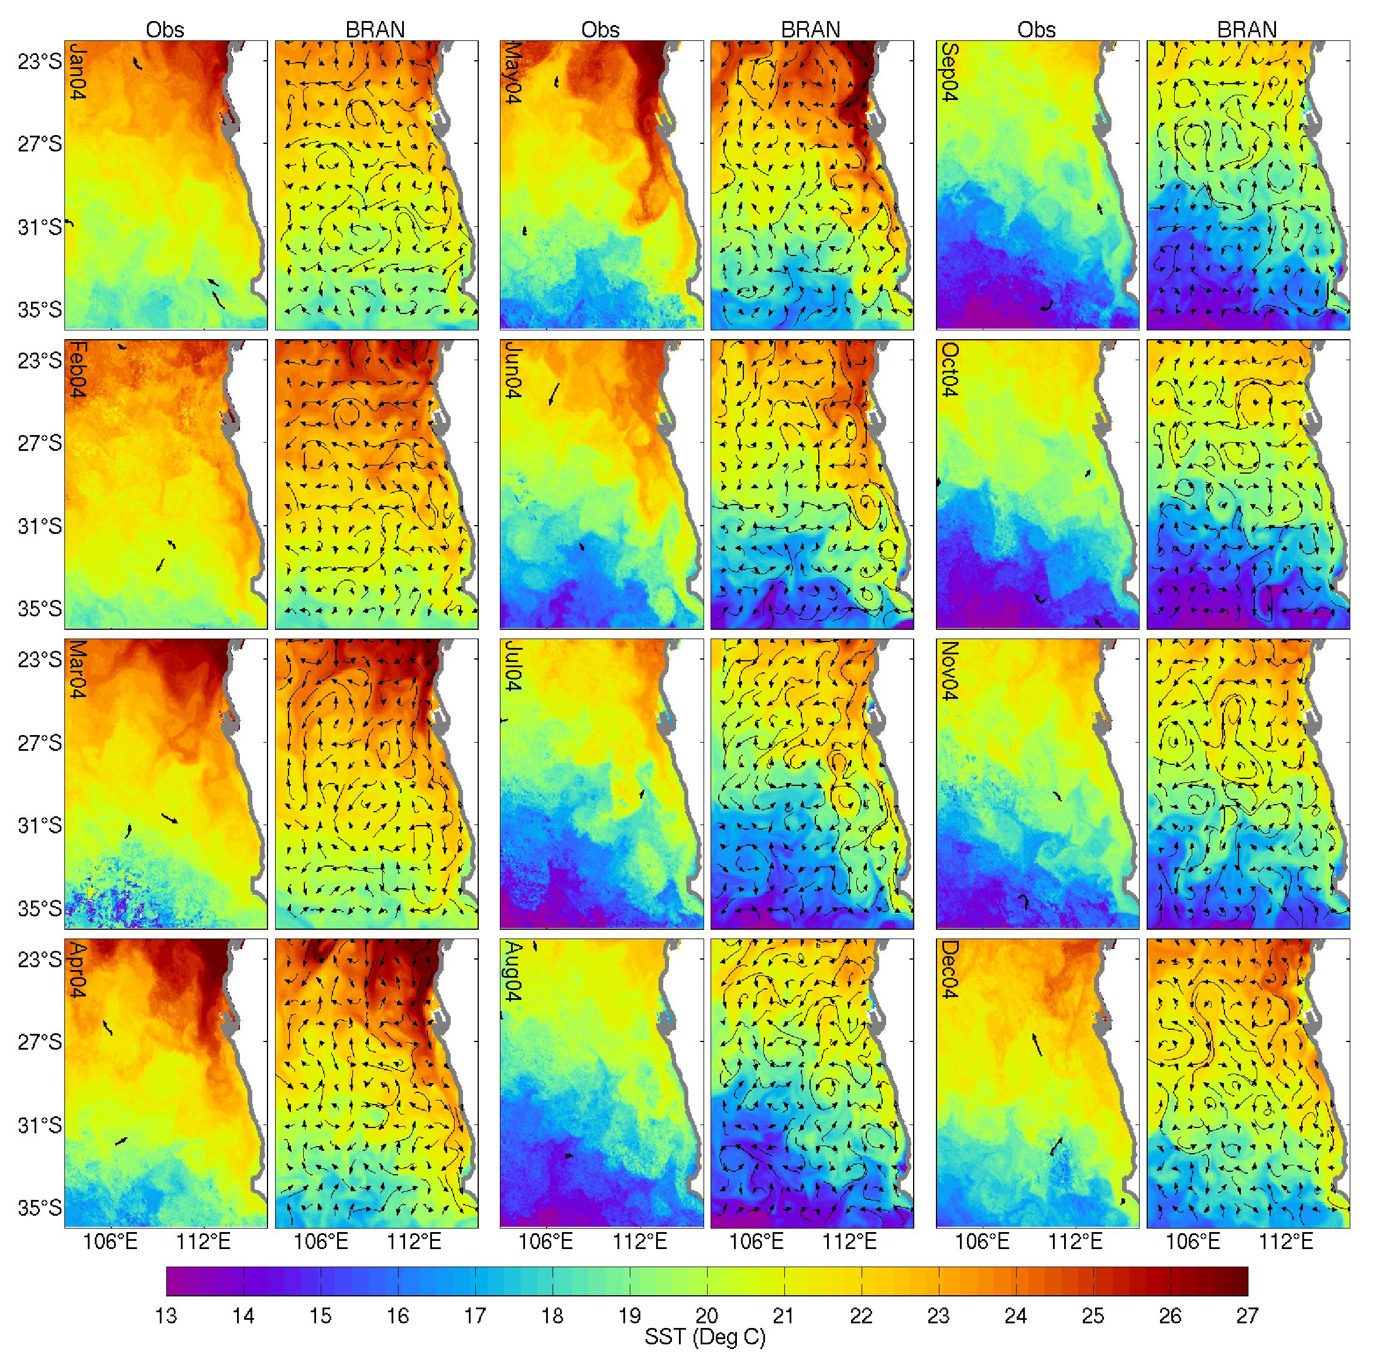
Figure 2: Comparisons between observed and reanalyzed SST, demonstrating the good quantitative skill of the Bluelink forecast system. Columns 1, 3 and 5 show 6-day composite SST from AVHRR measurements. Column 2, 4 and 6 show the corresponding 5-day averaged SST from BRAN. Comparisons are shown for the 15th day of each month of 2004, as labelled in the panels showing observations. Overlaying the BRAN SST are Lagrangian trajectories, computed from the time-dependent surface velocities from BRAN over the 5-day averaging period. Overlaying the observed SST are paths of observed surface drifting buoys; adapted from Oke et al. (2007).
[Figure showing comparisons between observed and reanalysed SST]

REFERENCES

Bishop, C., B. Etherton, and S. J. Majumdar, 2001: Adaptive sampling with the ensemble transform Kalman filter. part i: theoretical aspects. Monthly Weather Review, 129, 420–436.
Griffes, S. M., R. C. Pacanowski, and A. Rosati, 2004: A technical guide to MOM4, GFDL Ocean Group Technical Report No. 5. NOAA/Geophysical Fluid Dynamics Laboratory, 371 pp.
Oke, P. R., A. Schiller, D. A. Griffin and G. B. Brassington, 2005: Ensemble data assimilation for an eddy-resolving ocean model, Quarterly Journal of the Royal Meteorology Society, 131, 3301-3311.
Oke, P. R., P. Sakov, S. P. Corney, 2006: Impacts of localisation in the EnKF and EnOI: Experiments with a small model, Ocean Dynamics, http://dx.doi.org/10.1007/s10236-006-0088-8.

PUBLICATIONS

Oke, P. R., and A. Schiller, 2007a: A model-based assessment and design of a tropical Indian Ocean mooring array, Journal of Climate, 20, 3269-3283. [published, refereed]
Oke, P. R., and A. Schiller, 2007b: Impact of Argo, SST and altimeter data on an eddy-resolving ocean reanalysis. Geophysical Research Letters, [in press, refereed].
Sakov, P., and P. R. Oke, 2007a: Objective array design: Application to the tropical Indian Ocean. Journal of Atmospheric and Oceanic Technology , [in press, refereed].

Preprints of submitted manuscripts are available from http://www.cmar.csiro.au/staff/oke/.

