Enhanced Ocean Prediction using Ensemble Kalman Filter Techniques

Dr Peter R. Oke
CSIRO Marine and Atmospheric Research
GPO Box 1538 Hobart TAS 7001 Australia
phone: (+61 3) 6232-5387 fax: (+61 3) 6232-5123 email: peter.oke@csiro.au
Award Number: N00014-04-0345, including partial support from ONR Global's Naval International Cooperative Opportunities Program (NICOP).

LONG-TERM GOALS

To apply optimal data assimilation techniques to ocean circulation models in order to improve short-range prediction of mesoscale features.

OBJECTIVES

The immediate scientific objective of this research project is to develop a data assimilation system, based on ensemble Kalman Filter (EnKF) techniques, and to apply this system to a realistic eddy-resolving ocean circulation model.

APPROACH

The basic elements of an ensemble-based data assimilation system have been developed under this project and applied to a suite of ocean circulation models. The Bluelink Ocean Data Assimilation System (BODAS) is an Ensemble Optimal Interpolation (EnOI) system that uses a similar approach to that described by Oke et al. (2002). BODAS has been developed under a closely related project, Bluelink: Ocean Forecasting Australia. BODAS is a stand-alone assimilation system that computes an analysis of the three-dimensional ocean circulation by combining the relevant elements of an ensemble of anomalies of model variables, a model forecast and a range of observations. BODAS is transferable between different models and between different applications. To date, BODAS has been applied to 6 different models, ranging from high-resolution coastal ocean models, eddy resolving global ocean models and coarse resolution global model. These applications have used rectangular, polar and general curvilinear coordinates and have focused on time-scales ranging from hours to years.

An EnKF version of BODAS has been developed and applied to a high-resolution, regional ocean model. This version of BODAS involves an ensemble of model runs being performed in parallel; each with explicit representation of model error. BODAS derives statistics from this ensemble to estimate the forecast error covariances necessary for assimilation. The research challenges involved in this development are mostly related to the generation of the initial ensemble and to the representation of model error.

Comparisons between the performance of an EnKF and other related filters (e.g., Square-root Filter and EnOI) have been undertaken for various idealised models. This study has provided insight into the dependence of various ensemble-based filters to factors like ensemble size, covariance localization and observation density. Results from this study have been submitted for publication (Oke et al. 2005).

Key individuals:

Dr. Peter Oke is the P.I. on this project and leads the data assimilation group at CSIRO Marine and Atmospheric Research (CMAR).

Dr. Stuart Corney has a background in numerical modeling and inverse methods and is a Postdoctoral Research Associate at CMAR.

Dr. Pavel Sakov is investigating methods for the design of optimal observing systems using techniques that are derived from data assimilation methods.

The US-based researchers involved in this project are Dr. R. Miller, Dr. G. Jacobs and Dr. H. Ngodock. Each has a long history of research in the area of ocean data assimilation. The P.I. visited the US-based researcher’s institutions in November 2004 to formally initiate our collaboration.

WORK COMPLETED

The primary test bed for BODAS has been the Ocean Forecasting Australia Model (OFAM), a global configuration of MOM4.0, with 10 km resolution around Australia. In combination, BODAS and OFAM have been combined for the Bluelink ReANalysis (BRAN), a 13-year reconstruction of the global ocean circulation that has involved the assimilation of all available observations. The OFAM/BODAS forecast system will undergo operational trials at the Australian Bureau of Meteorology starting in late 2005. Results are described by Oke et al. (2005) and are publicly available at http://www.marine.csiro.au/bluelink/exproducts/index.htm.

Experiments with the EnKF have been conducted on a high resolution regional configuration of MOM4.0 for Bass Strait, Australia. Comparisons between the performance of EnOI (BODAS with a stationary ensemble of model anomalies) and the EnKF are underway. Experiments have been conducted to assess the sensitivity of BODAS to different ensemble fields; and of the EnKF to a different initial ensemble and to different parameterisations of model error.

We have completed an idealised study that compares the performance of an EnKF and EnOI when applied to a two-variable linear system. In this study we investigated the impact of localizing the ensemble-based forecast error covariances and the impact this has on the dynamical balances that are inherent in the model.

RESULTS

Comparison with independent observations indicates that BRAN successfully represents the true history of the near-surface mesoscale circulation around Australia for the past decade. For example, Figure 1 demonstrates excellent agreement between the paths taken by un-assimilated satellite-tracked surface drifters and the BRAN sea-level anomaly fields. Similarly, Figure 2 shows good agreement between the observed and reanalyzed upwelling off Java during the onset of the 1997 El Nino. A similar comparison off the coast of Western Australia (Figure 3) also demonstrates good qualitative agreement between modeled and observed sea surface temperature features that both reflect the independent drifter paths. While the comparisons presented in Figures 1-3 are favourable, we note that BRAN is not always in as close agreement with independent observations. For example, BRAN has a warm bias that has been traced to the surface fluxes. This is evident in the different temperature scales used in Figures 2 and 3. Also, the mesoscale features in the Tasman Sea and off Western Australia are not always in good agreement with independent observations. The reasons for this are under investigation.

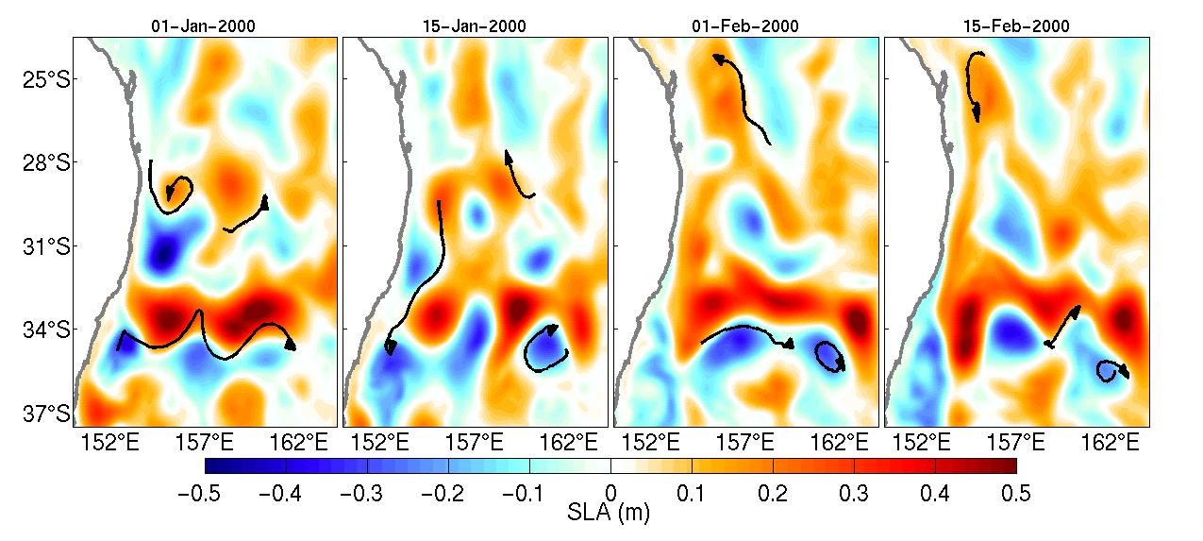
Figure 1: A sequence of maps of analyzed sea-level anomaly (15-day averages) from BRAN and surface drifter tracks for the 15 day period centered at the specified date in early 2000.

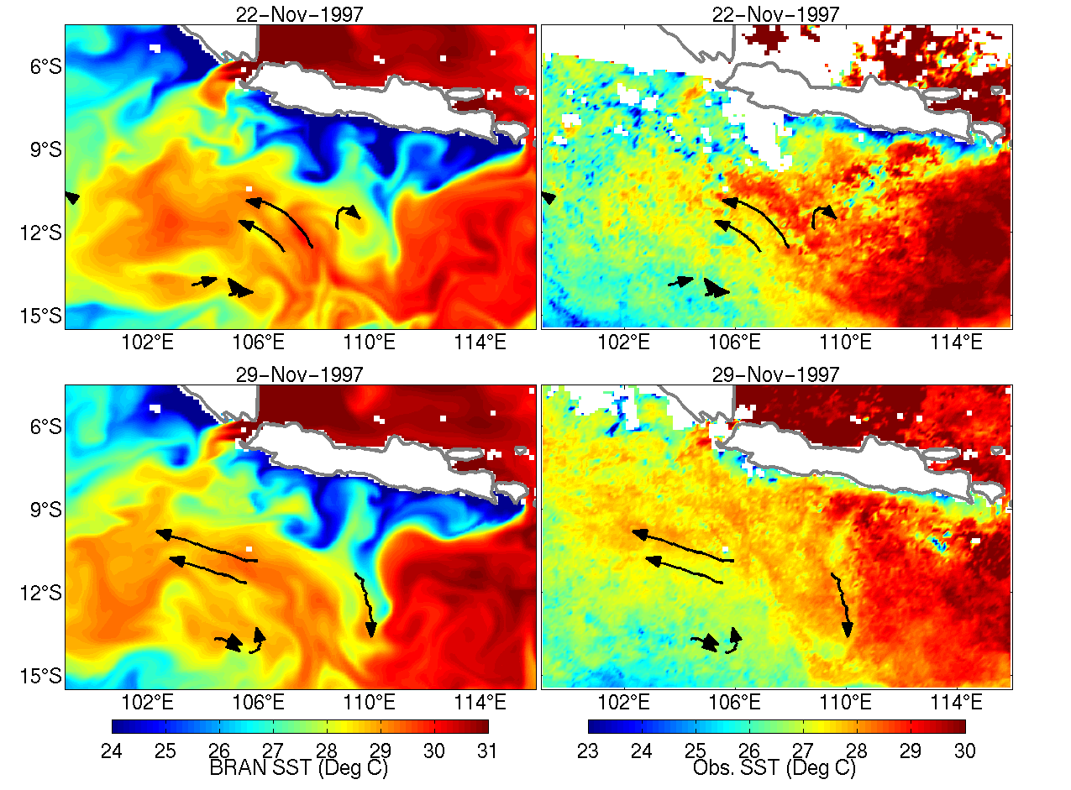
Figure 2: A sequence of maps off Java, showing daily averaged sea-surface temperature from BRAN (left) and from a 3-day composite from AVHRR (right) and independent surface drifter tracks for the 7 day period centered at the specified date.

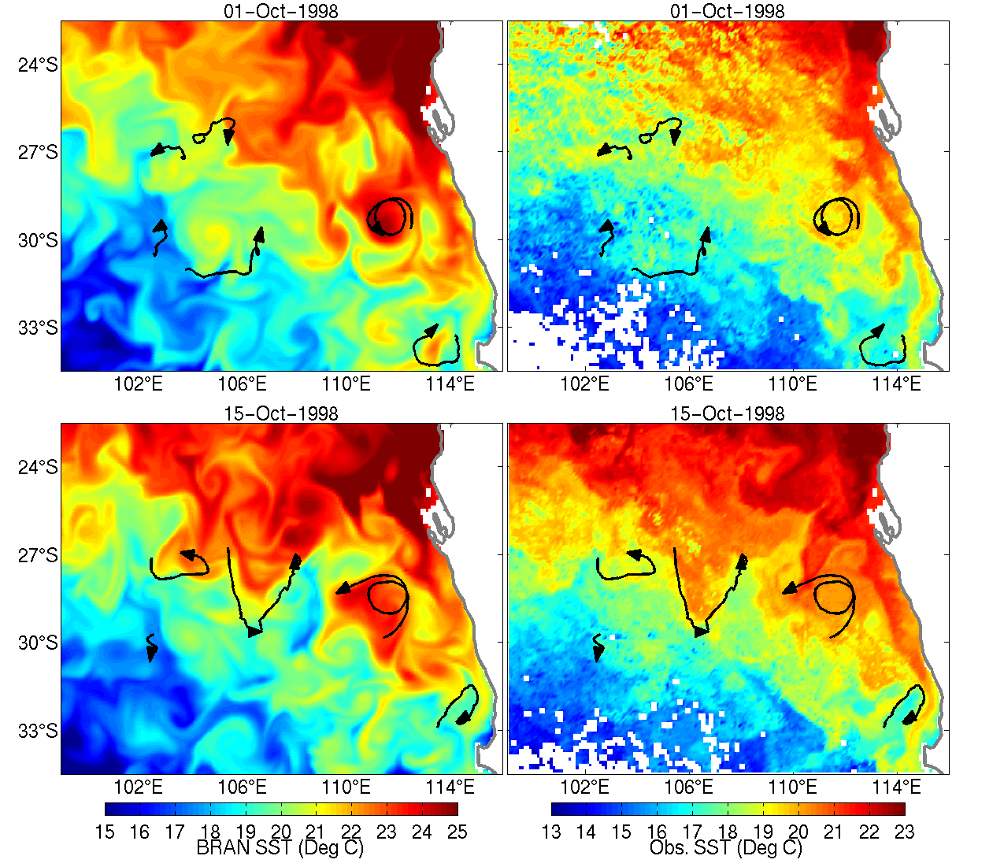
Figure 3: As for Figure 2, except off Western Australia and showing surface drifters over the 15 day period centered on the specified date.

Results from an identical twin experiment where the model and forcing fields are assumed to be perfect and the only source of error is assumed to be initial conditions are shown in Figure 4. A stationary 20-member ensemble of anomalies from a long time mean of a free model run is used for EnOI. The initial ensemble for the EnKF is the same as that for EnOI and no explicit model error is added to the ensemble members. Sea surface temperature measurements from a uniform, 10 by 5 observation array in Bass Strait are assimilated once a day. The results, in Figure 4, show the forecast error one day after assimilation for the EnKF (results are shown for the ensemble mean) and EnOI. Clearly, the EnKF performs better than EnOI.

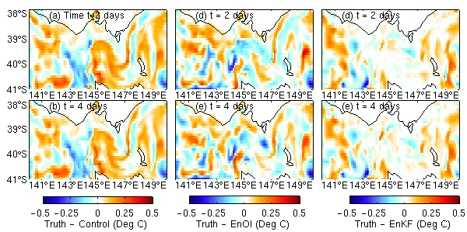
Figure 4: Forecast error for the control (a-b), EnOI (c-d) and the EnKF (d-e) for an identical twin experiment for the Bass Strait model.

Additional experiments with the EnKF have been conducted to investigate the impact of different methods for representing model error. These methods include the addition of spatially correlated noise (Evensen 2003), perturbation to observations (Houtekamer and Mitchell 1998) and the perturbation of the source terms in the model equations. The perturbation of the source terms gives dynamically consistent ensemble fields and is giving promising results.

We have examined the impact of masking when a small ensemble size is applied to a linear advection model. This model evolves two variables that are intended to be proxies for dynamic height, D, and velocity, V. The variable V is initialized as the spatial derivative of D. Only D is “observed”, but both D and V adjusted during the assimilation. We find that as the ensemble size is reduced, localization becomes important for obtaining satisfactory results. However, we also find that when the length-scale of the localization is shorter than the de-correlation length-scale of the variables, the dynamical balances of the model are compromised. This can have serious consequences for applications to non-linear models since it potentially amplifies the shock that a model undergoes when it is updated through assimilation. This suggests that if localization is necessary, balance constraints such as geostrophic adjustment (e.g., Burgers et al. 2002) should be considered. The results from this study are being prepared for publication.
IMPACT/APPLICATIONS

This research involves the development of a data assimilation tool that will be suitable for a variety of ocean models and configurations. We are particularly focused on making this tool useful for short-range prediction of mesoscale variability. We anticipate that this tool will be valuable for all agencies involved in this project.

TRANSITIONS

In the final year of this project, the EnKF version of BODAS will be transitioned to the NRL. As a first step towards this transition, the documentation for BODAS has been sent to NRL scientists Dr H. Ngodock and Dr. G. Jacobs.

RELATED PROJECTS

The BLUElink: Ocean Forecasting Australia project (http://www.marine.csiro.au/bluelink/) is a partnership between CSIRO, the Australian Bureau of Meteorology and the Royal Australian Navy. BLUElink has a number of streams that include the development and application of OFAM and BODAS, the operational production of near-real-time analyses of oceanographic variables around Australia (http://www.marine.csiro.au/remotesensing/oceancurrents/) and the development of an improved regional climatology (http://www.marine.csiro.au/~dunn/eez_data/atlas.html), amongst other activities.

Some streams of research undertaken at CSIRO are directed towards the design of optimal observing systems. These research activities are closely related to issues like ensemble generation and the sensitivity of ocean models. Under this project, we have developed a new method for observing system design. This method uses the principles of ensemble data assimilation to determine an observing system that should produce optimal results when combined with a data assimilating model. This method has been tested for the design of the Tropical Indian Ocean mooring array and is described by Oke and Schiller (2005).

REFERENCES

Burgers, Gerrit, Balmaseda, Magdalena A., Vossepoel, Femke C., van Oldenborgh, Geert Jan, van Leeuwen, Peter Jan. 2002: Balanced Ocean-Data Assimilation near the Equator. Journal of Physical Oceanography, 32, 2509–2519.
Evensen, G., 2003: The ensemble Kalman Filter: theoretical formulation and practical implementation. Ocean Dyn., 53, 343-367.
Houtekamer, P. L., H. L. Mitchell, 1998: Data Assimilation Using an Ensemble Kalman Filter Technique. Mon. Weath. Rev., 126, 796-811.
Oke, P. R., J. S. Allen, R. N. Miller, G. D. Egbert and P. M. Kosro, 2002: Assimilation of surface velocity data into a primitive equation coastal ocean model. Journal of Geophysical Research, 107, doi:10.1029/200JC000511.

PUBLICATIONS

Oke, P. R., A. Schiller, D. A. Griffin and G. B. Brassington, 2005: Ensemble data assimilation for an eddy-resolving ocean model, Quarterly Journal of the Royal Meteorology Society, accepted.
Oke, P. R., and A. Schiller, 2005: A model-based assessment and design of a tropical Indian Ocean mooring array, Journal of Climate, accepted.
Oke, P. R., P. Sakov, S. P. Corney, 2005: Practical ensemble data assimilation using a small ensemble size, Ocean Dynamics, submitted.

