Enhanced Ocean Prediction using Ensemble Kalman Filter Techniques

Dr Peter R. Oke
CSIRO Marine Research
GPO Box 1538 Hobart TAS 7001 Australia
phone: (+61 3) 6232-5387 fax: (+61 3) 6232-5123 email: peter.oke@csiro.au
Award Number: N00014-04-0345, including partial support from ONR Global's Naval International Cooperative Opportunities Program (NICOP).

LONG-TERM GOALS

To apply optimal data assimilation techniques to ocean circulation models in order to improve short-range prediction of mesoscale features.

OBJECTIVES

The immediate scientific objective of this research project is to develop a data assimilation system, based on ensemble Kalman Filter (EnKF) techniques, and to apply this system to a realistic eddy-resolving ocean circulation model.

APPROACH

The basic elements of an ensemble-based data assimilation system include a system for solving the analysis equations, collating and preparing observations, initializing and integrating an ensemble of forecasts and estimating model errors. Each of these components are currently under development and are being systematically tested on a suite of models ranging from a simple linear and non-linear system of differential equations, to an idealized and realistic ocean circulation model.

The BLUElink Ocean Data Assimilation System (BODAS) has been developed by the P.I. under a closely related project, BLUElink: Ocean Forecasting Australia (see related projects for details). ODAS is a stand-alone assimilation system that computes an analysis of the three-dimensional ocean circulation by combining the relevant elements of an ensemble of anomalies of model variables, a model forecast and a range of observations. BODAS has been designed to be transferable between different models and between different applications. During the development phase, BODAS has been applied using a stationary ensemble of anomalies (i.e., Ensemble-based Optimal Interpolation EnOI; Oke et al. 2000). Under this project, BODAS utilizes state-dependent anomalies (i.e., as in an EnKF). BODAS is currently being applied to the Ocean Forecasting Australia Model (OFAM; developed by A. Schiller under BLUElink), a global configuration of MOM4.0, with eddy-resolving resolution around Australia. In combination, BODAS and OFAM will comprise an ocean forecasting system that is planned to be implemented operationally at the Australian Bureau of Meteorology following the conclusion of the BLUElink project. The main activities under BLUElink are the development, testing and implementation of the BLUElink forecast system; and a multi-year hind-cast experiment (1992-2002).

Comparisons between the performance of an EnKF and other related filters (e.g., Square-root Filter and EnOI) have been undertaken by the P.I. together with S. Corney and P. Sakov for a linear, two-component system. Although this model is not directly related to oceanic applications, it has enabled us to compare the performance of various ensemble-based filters; to examine the sensitivity and robustness of each filter to factors like ensemble size, covariance localization, observation density; and to assess the skill in the ensemble-based multivariate covariances for a simple system where the dynamical balances are known exactly.

Work on how to best initialize an ensemble of forecasts has been undertaken by the P.I. together with P. Sakov. In this study we have compared the effectiveness of initializing with perturbations derived from singular vectors and other related diagnostics in order to assess how we could proceed to initialize an ensemble of forecasts for a non-linear model where the tangent linear model and its adjoint are not readily available.

Key individuals:
Dr. Peter Oke is the P.I. on this project and leads the data assimilation group at CSIRO Marine Research (CMR). Dr. Oke is responsible for the development of BODAS under the BLUElink project.

Dr. Stuart Corney has a background in numerical modeling and inverse methods and was hired by CMR in April 2004 to conduct research under this project.

Dr. Pavel Sakov is currently investigating methods for the design of optimal observing systems under the CSIRO Wealth from Oceans flagship program.

Dr. Andreas Schiller is one of the principal investigators of BLUElink and is responsible for developing OFAM. Dr. Schiller has a long history of experience in global ocean modeling.

The US-based researchers involved in this project are Dr. R. Miller and Dr. G. Jacobs. Both have a long history of research in the area of ocean data assimilation. The P.I. will visit the US-based researcher’s institutions in November 2004 to formally initiate our collaboration.

WORK COMPLETED

The majority of the development for BODAS, an ensemble-based multivariate data assimilation system, is now complete. A series of identical twin experiments have been undertaken to verify that BODAS works effectively under idealized conditions. Applications with real observations have also been undertaken to validate the effectiveness of the system. Various components of BODAS are currently being tuned for application to OFAM in preparation for a multi-year hind-cast experiment.

We have completed a study that compared the performance of an EnKF, EnSRF and EnOI when applied to a two-variable linear system that is similar to the application described by Evensen (2004). In this study we have investigated the impact of localizing the ensemble-based forecast error covariances (e.g., Houtekamer and Mitchell 2001) and the impact this has on the dynamical balances that are inherent in the model.

We have configured MOM4.0 for an idealized model of the mesoscale circulation in Bass Strait (between Victoria and Tasmania, Australia). An ensemble of simulations has been performed and covariances have been analyzed in preparation for an application of BODAS to this configuration. A configuration of MOM4.0 for the mesoscale ocean circulation in the Tasman Sea is also underway. These models will act as the test-bed for the EnKF-based assimilation system that is being developed under this project.

To address the problem of initializing an ensemble of forecasts, we have applied the Arnoldi algorithm (e.g., Sorensen 1992) using ARPACK, a freely available package (http://www.caam.rice.edu/software/ ARPACK), to compute finite time eigenmodes (FTEs; e.g., Moore et al. 2003) of various non-linear models. We’re investigating the suitability of using FTEs for ensemble initialization. FTEs offer a practical alternative to singular vectors for ensemble initialization (e.g., Molteni et al. 1996) since they do not require a tangent linear model or an adjoint for their computation.

RESULTS

To date, applications of BODAS have used a stationary ensemble to estimate the forecast error covariances, following a similar method to that described by Oke et al. 2002. The suitability of these anomalies for assimilation of satellite-derived sea-level anomaly and in situ temperature and salinity profiles into OFAM has been demonstrated through a series of twin experiments. For example, Figure 1 shows a section of a forecast (top left), analysis (bottom left) and the true temperature off NW Australia for a twin experiment where simulated SLA from T/P tracks were assimilated.

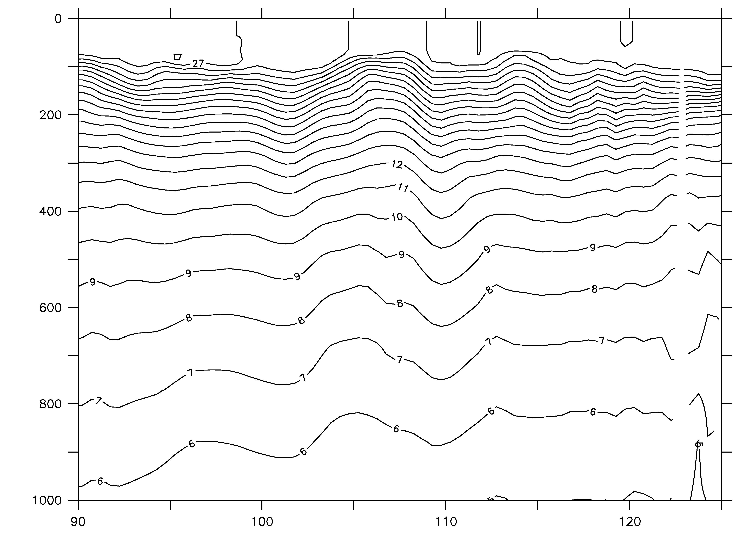 | 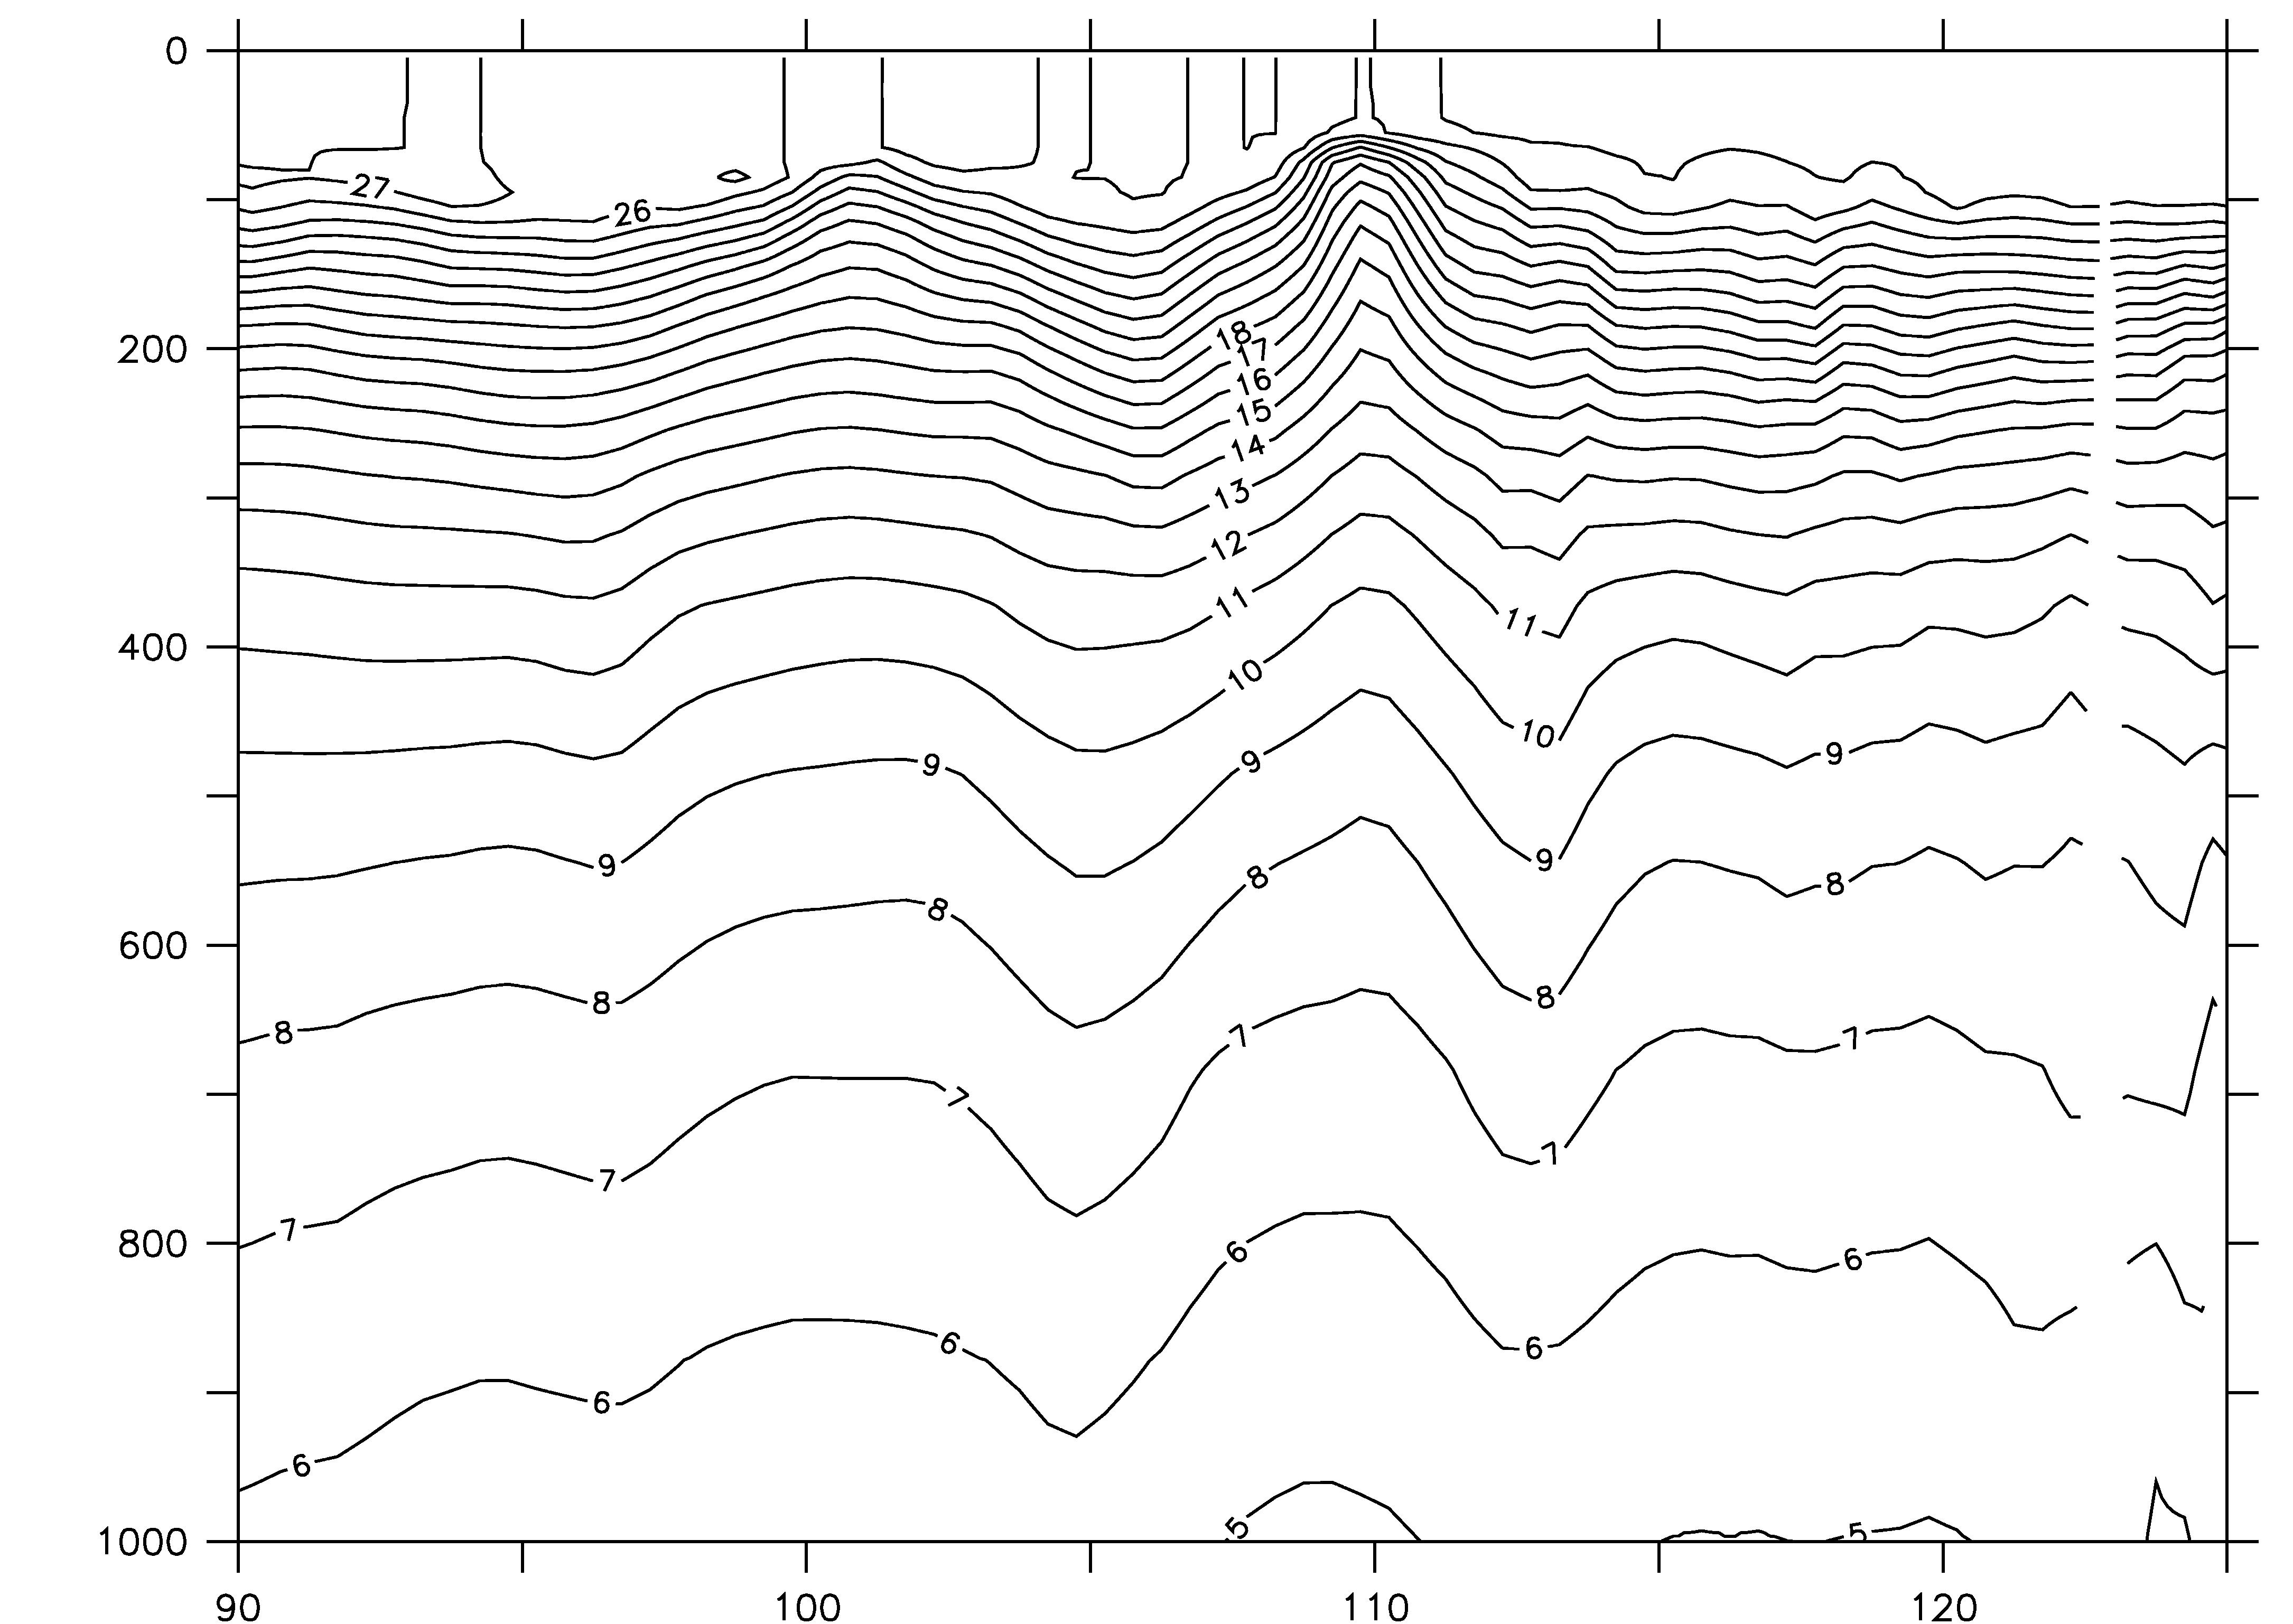
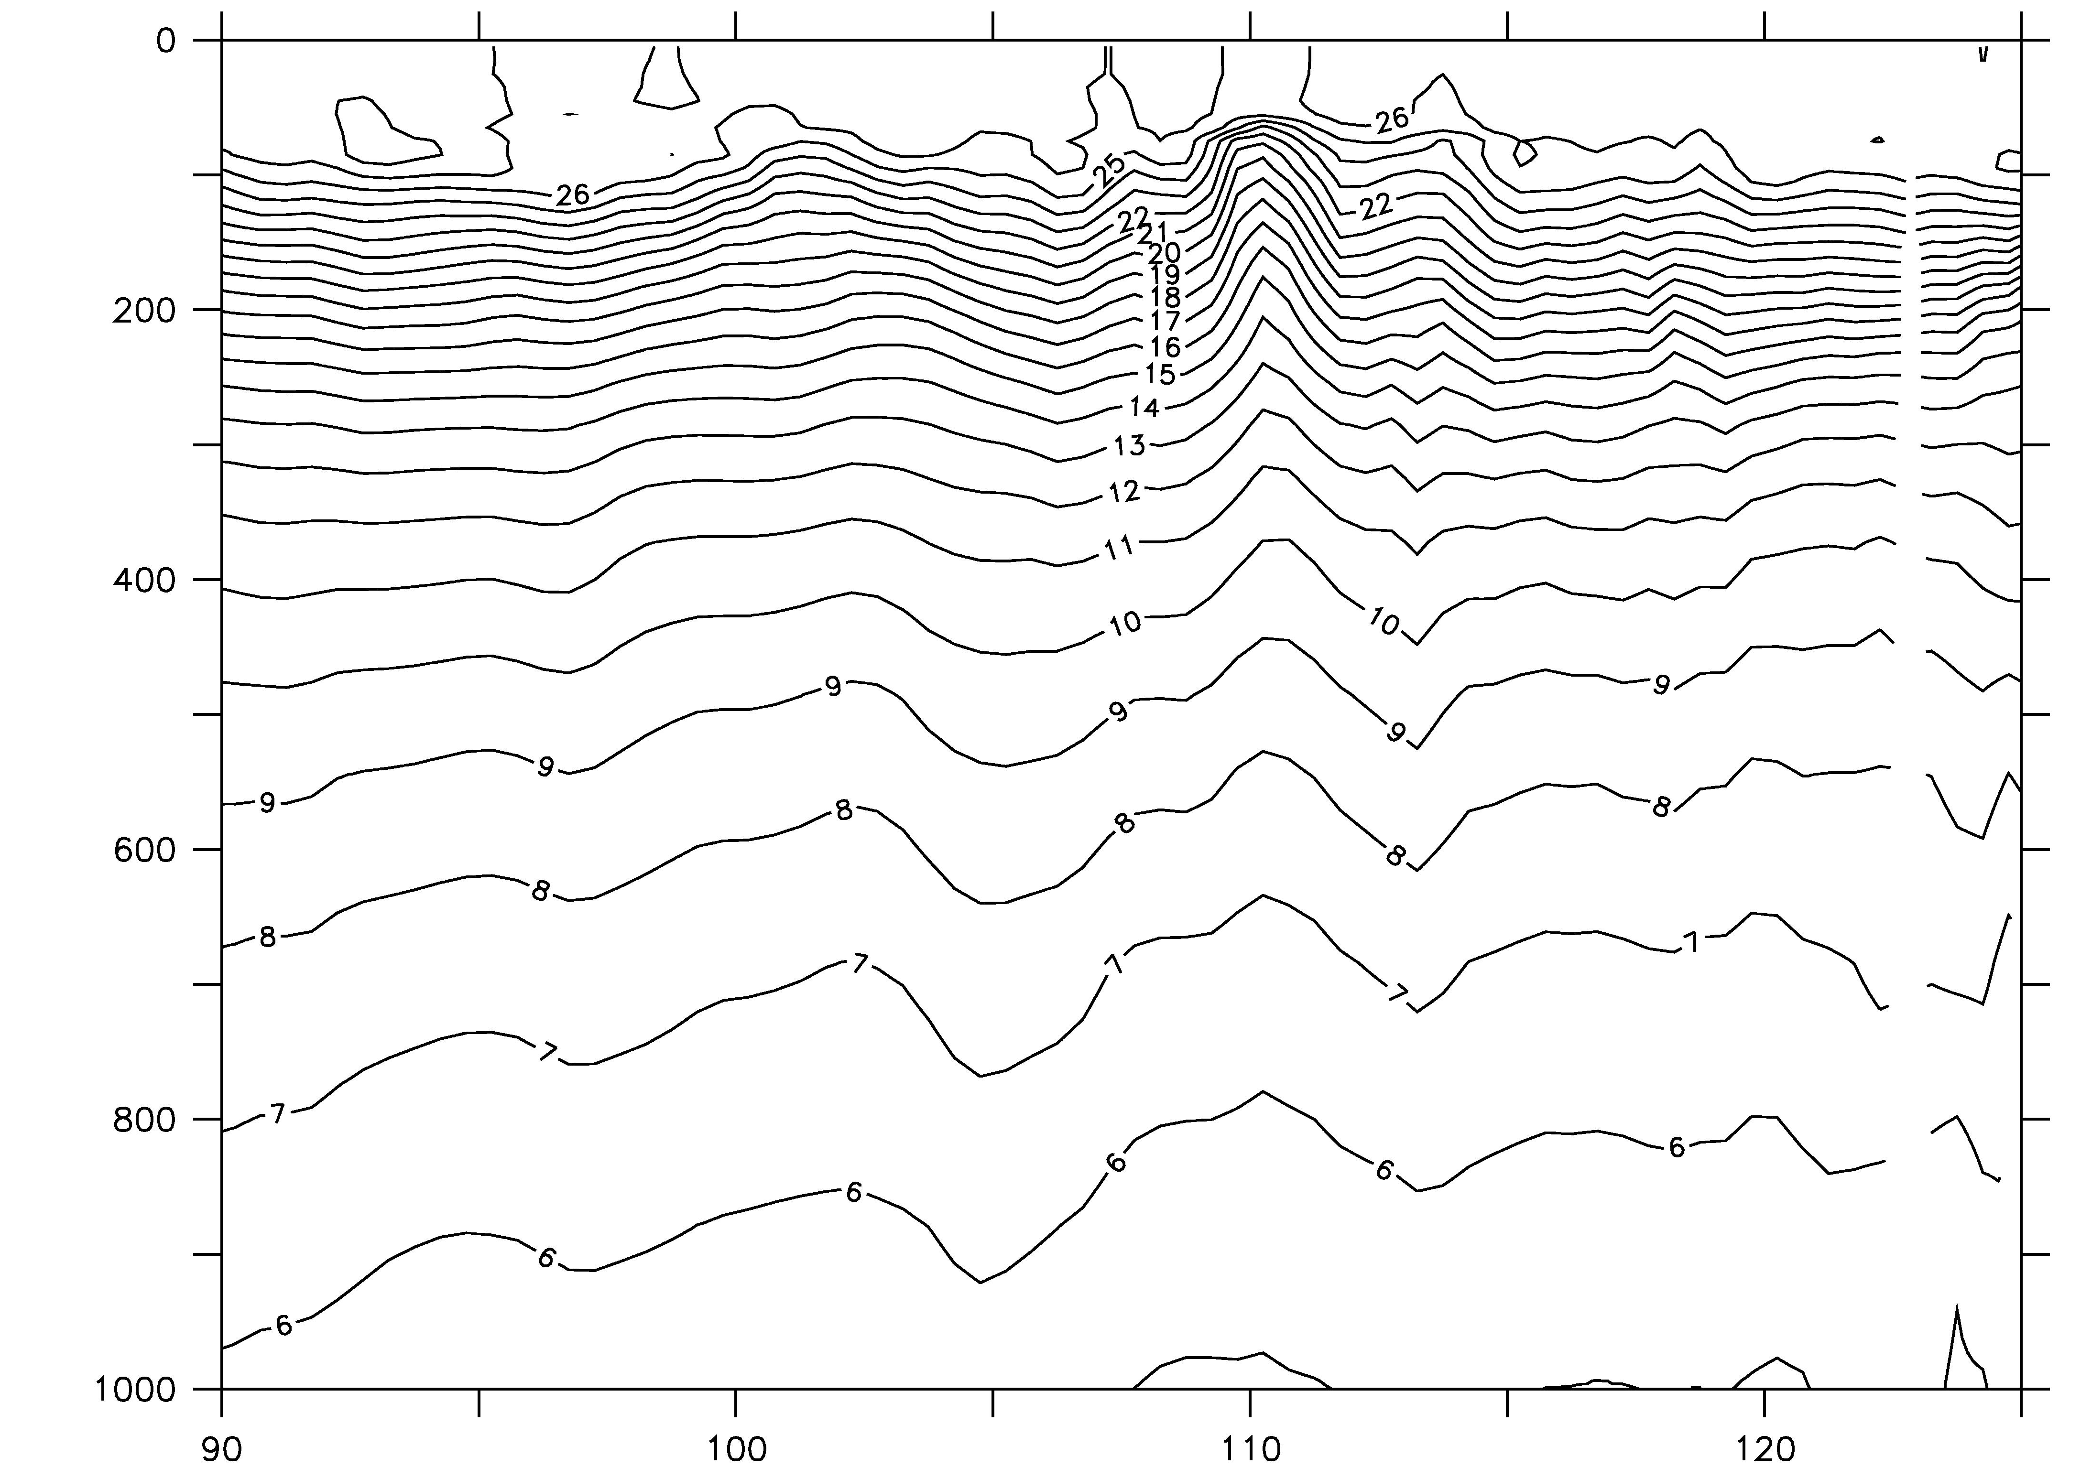
Figure 1: Temperature sections (in degrees C) at 10ºS, between 90ºE and 123ºE, south of Indonesia showing the forecast (top left), true state (top right) and the analysis (bottom left). The horizontal axis is longitude and the vertical axis is depth (m).

When a small ensemble is used to estimate the forecast error covariances needed for assimilation, sampling error can degrade the solution (e.g., Hamill et al. 2001). In this situation, the covariances are often localized, or masked, around each observation (Houtekamer and Mitchell 2001). This artificially limits the spatial region of influence of each datum. An example of the impact of masking on the ensemble-based covariance, computed using 48 anomalies, between sea-level at a fixed point and sea-level off Eastern Australia, is shown in Figure 2. Without masking, a sea-level observation from the reference location could result in an adjustment to the model state over the large region where the covariance is non-zero. It is unclear whether this non-zero covariance is realistic, or the result of sampling error. The effect of masking is that the non-zero covariances are restricted to the region immediately surrounding the observation. We have examined the impact of masking when a small ensemble size is applied to a linear advection model. This model evolves two variables that are intended to be proxies for dynamic height, D, and velocity, V. The variable V is initialized as the spatial derivative of D. Only D is “observed”, but both D and V adjusted during the assimilation. We find that as the ensemble size is reduced, localization becomes important for obtaining satisfactory results. However, we also find that when the length-scale of the localization is shorter than the de-correlation length-scale of the variables, the dynamical balances of the model are compromised. This can have serious consequences for applications to non-linear models since it potentially amplifies the shock that a model undergoes when it is updated through assimilation. This suggests that if localization is necessary, balance constraints such as geostrophic adjustment (e.g., Burgers et al. 2002) should be considered. The results from this study are being prepared for publication.

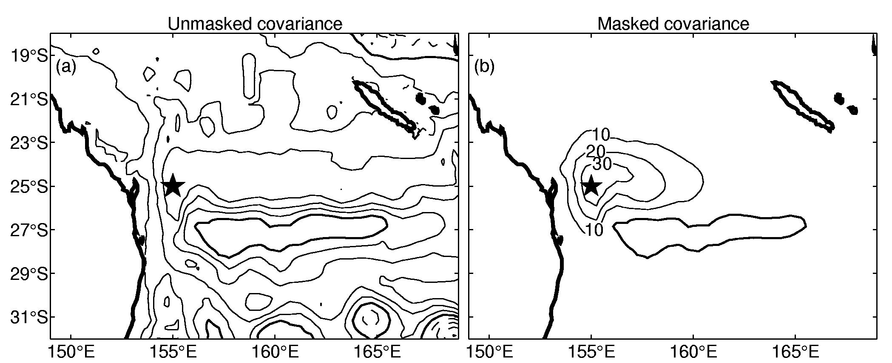
Figure 2. Ensemble-based covariances between sea-level at (155ºE, 25ºS) and sea-level off Eastern Australia, (a) without masking and (b) with masking. The contour intervals for the covariance plots are 10 cm². Bold contours denote zero. The reference location is denoted by the star.

Our initial experiments using ARPACK for calculating FTEs have involved applications to the idealized, non-linear model described by Lorenz and Emanuel (1998). Simulations with this model, in which eigenvectors, adjoint eigenvectors, finite time eigenmodes, adjoint finite time eigenmodes, and singular vectors have been successfully calculated for system size of up to 10000, demonstrate the robustness of ARPACK for calculating eigenmodes in large-scale non-linear systems. We are currently working on an application of ARPACK to various configurations of non-linear ocean models and will subsequently investigate the suitability of using FTEs for generating an initial ensemble for applications of an EnKF.

IMPACT/APPLICATIONS

This research involves the development of a data assimilation tool that will be suitable for a variety of ocean models and configurations. We are particularly focused on making this tool useful for short-range prediction of mesoscale variability. We anticipate that this tool will be valuable for all agencies involved in this project.

RELATED PROJECTS

The BLUElink: Ocean Forecasting Australia project (http://www.marine.csiro.au/bluelink/) is a partnership between CSIRO, the Australian Bureau of Meteorology and the Royal Australian Navy. BLUElink has a number of streams that include the development and application of OFAM and BODAS, the operational production of near-real-time analyses of oceanographic variables around Australia (http://www.marine.csiro.au/remotesensing/oceancurrents/) and the development of an improved regional climatology (http://www.marine.csiro.au/~dunn/eez_data/atlas.html), amongst other activities.

Some streams of research directed towards initialization of ensemble forecasts are funded under the CSIRO flagships program entitled “Wealth from Oceans”. This is a program run within CSIRO that seeks to deliver real tangible benefits from oceanographic research to the Australian community. A key element of Wealth from Oceans is the enhancement of our ocean forecasting capabilities.

REFERENCES

Burgers, Gerrit, Balmaseda, Magdalena A., Vossepoel, Femke C., van Oldenborgh, Geert Jan, van Leeuwen, Peter Jan. 2002: Balanced Ocean-Data Assimilation near the Equator. Journal of Physical Oceanography, 32, 2509–2519.
Evensen, G., 2004: Sampling strategies and square root analysis schemes for the EnKF. Ocean Dynamics, submitted.
Hamill, T. M., J. S. Whitaker and C. Snyder, 2001: Distance-dependent filtering of background error covariance estimates in an ensemble Kalman filter. Monthly Weather Review, 129, 2776-2790.
Houtekamer, P., L. and H. L. Mitchell, 2001: A sequential ensemble Kalman filter for atmospheric data assimilation. Monthly Weather Review, 129, 123-137.
Lorenz, E. N. and K. A. Emanuel 1998: Optimal sites for supplementary weather observations: simulation with a small model. Journal of Atmospheric Sciences, 55, 399-414.
Molteni, F., R. Buizza, T. N. Palmer and T. Petroliagis, 1996: The ECMWF ensemble prediction system: Methodology and validation. Quarterly Journal of the Royal Metrological Society, 122, 73-119.
Moore, A. M., H. G. Arango, E. Di Lorenzo, B. D. Cornelle, A. J. Miller and D. J. Neilson, 2003: A comprehensive ocean prediction and analysis system based on the tangent linear and adjoint of a regional ocean model. Ocean Modeling, 7, 227-258.
Oke, P. R., J. S. Allen, R. N. Miller, G. D. Egbert and P. M. Kosro, 2002: Assimilation of surface velocity data into a primitive equation coastal ocean model. Journal of Geophysical Research, 107, doi:10.1029/200JC000511.
Sorensen, D. C., 1992: Implicit application of polynomial filters in a k-step Arnoldi method. SIAM J. Matrix Analysis and Application, 13, 357-385.

