- Introduction
Bluelink is an Australian partnership between the Commonwealth Scientific and Industrial Research Organisation, the Bureau of Meteorology and the Royal Australian Navy. The primary objective of Bluelink is to develop a reanalysis and forecast system for the mesoscale ocean circulation in the Australasian region; specifically between 90ºE and 180ºE, and between 60ºS and 25ºN. To this end, the Ocean Forecasting Australia Model (OFAM; Schiller et al. 2005) has been configured. OFAM is a global ocean general circulation model, with approximately 10 km horizontal resolution around Australia. In addition to OFAM, the Bluelink Ocean Data Assimilation System (BODAS) has been developed (Oke et al. 2005). BODAS is an ensemble optimal interpolation (EnOI) system, similar to that introduced by Oke et al. (2002) and Evensen (2003). This paper describes the salient features of both OFAM and BODAS and presents some preliminary results from the Bluelink ReANalysis (BRAN), a 13-year ocean reanalysis using OFAM and BODAS.
- Model Configuration
The details of OFAM are described by Schiller et al. (2005) and Oke et al. (2005). For completeness, a brief summary of the model configuration is included below. OFAM is based on version 4.0 of the Modular Ocean Model (Griffies et al. 2004), with local modifications including the implementation of the hybrid mixed layer model described by Chen et al. (1994), a modified parameterisation for the penetration of solar radiation and various optimisations for an NEC SX6. OFAM is intended to be used for reanalyses (i.e., BRAN) and short-range ocean prediction. The horizontal grid has 1191 and 968 points in the zonal and meridional directions respectively; with 0.1º horizontal resolution around Australia as indicated in Figure 1. Outside of the Australasian domain, the horizontal resolution decreases to about 1º in the eastern Pacific and 2º in the North Atlantic Ocean. OFAM has 47 vertical levels, with 10 m resolution down to 200 m depth. The topography for OFAM is a composite of a range of different topography sources. Horizontal diffusion is modelled using isopycnal mixing. OFAM is initialised with a blend of climatologies from CARS2000 (CSIRO Atlas of Regional Seas; Ridgway et al. 2002) and Levitus (2001); and is forced at the surface using 6-hourly fluxes of momentum, heat and freshwater from ERA-40 (Kallberg et al. 2004) for 1992 to mid-2002; and using ECMWF 6-hourly forecasts from mid-2002 to 2004. A flux correction is also applied, restoring the sea surface temperature (SST) to a blend of Reynolds-SST (Reynolds and Smith 1994) and high-resolution satellite-derived observations; and restoring sea surface salinity (SSS) to monthly climatologies (Levitus 2001). The time-scale over which SST and SSS is restored to observations and climatology respectively is 30 days. OFAM is spun up without data assimilation for a 9 year simulation; covering the period 1993 to 2001. An analysis of the modelled trends of globally averaged sea-level indicates that the model reaches a state of quasi-equilibrium after 3 years of integration. Interior temperature and salinity properties require much longer to properly equilibrate. The last 6 years of the model-only simulation are used to construct the assimilation statistics as described below.

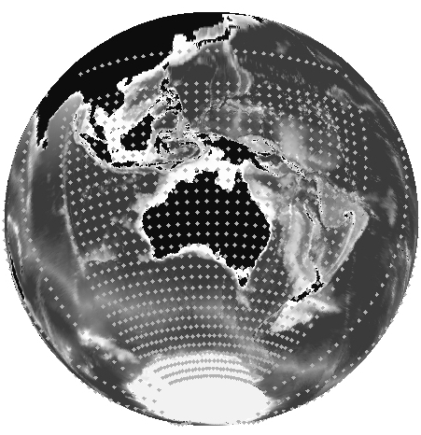
Figure 1: Model grid and topography showing every 30th horizontal grid point.
- Data Assimilation System
The Bluelink Ocean Data Assimilation System (BODAS) is described in detail by Oke et al. (2005). BODAS is an ensemble optimal interpolation (EnOI) system that can be considered as a poor cousin of the Ensemble Kalman Filter (EnKF). Specifically, the EnKF involves the parallel integration of n forecasts, where n is the ensemble size. These forecasts are converted to ensemble perturbations by removing the ensemble mean that is intended to represent the “best guess” forecast. The covariances of the ensemble perturbations are then used to approximate the Forecast Error Covariances (FECs) for assimilation. Each ensemble member is updated, using one of the many EnKF-based algorithms that are available, resulting in an ensemble of analyses that are used as initial conditions for the next forecast-analysis. By contrast, EnOI approximates the FECs using a stationary ensemble of model anomalies and only requires the integration of a single forecast.
It can be shown (Evensen 2003) that the analysis increments derived from EnKF-based systems, like BODAS, are merely a linear combination of ensemble perturbations. Because the ensemble anomalies, or perturbations, are stationary for EnOI, it is important that they represent the scales of variability that are appropriate for a given application. For application to OFAM a 72-member ensemble of intraseasonal model anomalies is used. This ensemble of model anomalies is intended to span the temporal- and spatial-scales that correspond to oceanic mesoscale variability. The model anomalies are generated from the 9 year model spin-up run, referred to in section 2. Specifically, the intraseasonal anomalies are computed by removing a 91-day running mean from a daily mean field produced by the model. One ensemble member is generated from each month of the final 6 years of the model spin-up run.
The ensemble-based FECs are localised around each observation to reduce the negative effects of sampling error that result from a relatively small ensemble size. Localisation also has the benefit of increasing the rank of the ensemble. The localisation is achieved by multiplying the FECs by the quasi-Gaussian, isotropic and homogeneous correlation function that is described by Gaspari and Cohn (1999). For applications to OFAM, this correlation function reduces the covariances to exactly zero over 8º. The FECs have characteristics that reflect the length-scales and the anisotropy of the ocean circulation in different regions (Oke et al. 2005). Localisation for ensemble-based assimilation systems has become common practice, despite the recognition that it compromises the dynamical consistency of the analyses.
BODAS is a flexible system that can assimilate observations of temperature, salinity and sea-level into a range of different models. To date, BODAS has been applied to high-resolution coastal and global models for short-range ocean prediction; and coarse resolution global ocean models for seasonal prediction. An EnKF version of BODAS has also been developed and is currently being tested in the context of an eddy-resolving, limited area model.
4. Reanalysis
One of the main activities under the Bluelink project is BRAN. BRAN is a 13-year run with data assimilation covering the period 1992-2004. BRAN is performed by assimilated observations into OFAM using BODAS. Observations that are assimilated include sea-level anomalies (SLA) from all altimeters (Table 1) and from a coastal tide gauge array around Australia; and temperature and salinity profiles from a range of field sources (Table 1). During the course of the BRAN integration, a total of 3.8x10⁵ (1.3x10⁵) temperature (salinity) profiles are assimilated; corresponding to about 1.1x10⁷ (3.2x10⁶) individual temperature (salinity) observations. Not all of the available profiles are assimilated. When several profiles are closely spaced, some profiles are considered redundant and are withheld for validation. During 2004, about 500 temperature and salinity profiles are assimilated during each assimilation cycle. BRAN is the first comprehensive ocean reanalysis that is eddy-resolving around Australia.
Table 1: Details of observations assimilated into BRAN.
Variables | Instrument | Source
Sea-level | GFO, Jason-1 | US NAVY/NAVO
Sea-level | Jason-1, Top./Pos. | JPL/PO.DAAC
Sea-level | ERS 1and 2; ENVISAT | ESA
Sea-level | Tide gauges | State agencies
Temperature and salinity | TAO | NOAA/ PMEL
Temperature and salinity | Argo | USGODAE / Coriolis
Temperature and salinity | XBT | GTS
5. Results
The focus of the Bluelink project is the development of a forecast system for the mesoscale ocean variability in the Australasian region (Figure 1). This has been achieved through the developments of OFAM and BODAS. Despite the regional focus, the Bluelink system employs a global ocean model. We therefore present a series of results that assess the performance of BRAN, firstly on a global scale; and secondly on a regional scale, with a focus on the Tasman Sea. We focus on the Tasman Sea because it represents the most energetic and eddy-rich environment in the Australian region. It therefore provides a significant challenge for forecast and re-analysis systems.
The global root-mean-squared (RMS) assimilation statistics for temperature profiles are shown in Figure 2. This shows the RMS observed minus 3-day forecast (OmF) profiles and the observed minus analysed (OmA) profiles for temperature. Results are included for both the assimilated and withheld observations. Clearly the best agreement is for the assimilated OmA; however the withheld OmA is very similar. Both show that the RMS error for temperature is greatest at about 100 m depth, where the seasonal thermocline typically resides; and decreases with depth and towards the surface. Equivalent statistics for the OmF demonstrate that over the 3 day period of each forecast, temperature error increases by 0.5-1ºC at 100-150 m depth.
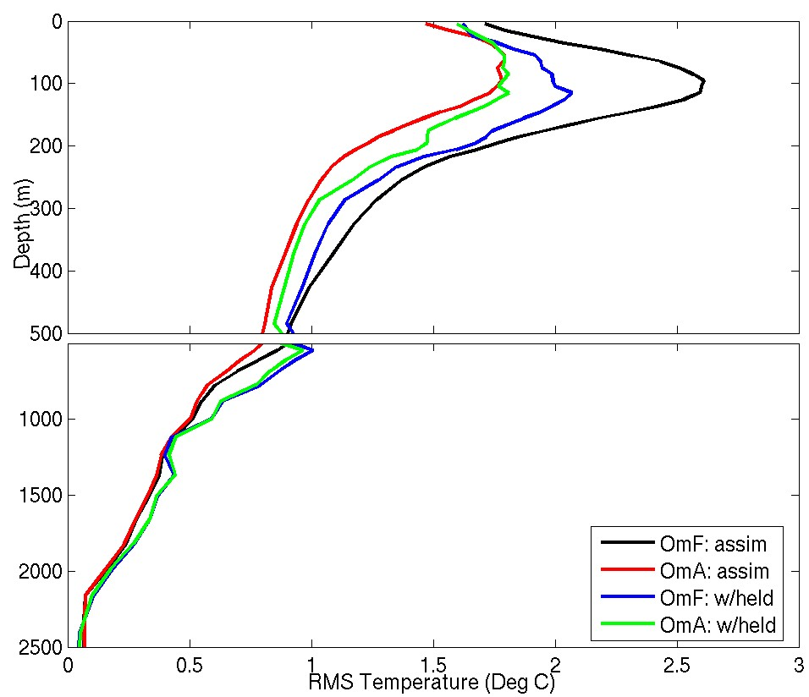
Figure 2: Global RMS observed minus 3-day forecast (OmF) and observed minus analysis (OmA) profiles for temperature in BRAN for both assimilated (denoted assim) and withheld (denoted w/held).
A large fraction of the mismatch between BRAN and the subsurface temperature observations is because BRAN has a warming trend due in part to the accidental omission of albedo in the incoming solar short wave radiation. In addition, the model’s surface mixed-layer is significantly deeper than observed. A re-run of the (non-assimilating) spin-up run with corrections to the surface forcing terms and mixed-layer scheme parameters has been performed. The results demonstrate a significant reduction in the warm bias. A new ensemble of model anomalies that are less contaminated by the trend and excess mixed-layer thickness have been computed and BRAN will soon be re-run.
The RMS OmA and OmF statistics for temperature profiles in the Tasman Sea are shown in Figure 3. The profile of OmA for the assimilated profiles demonstrates that BODAS is able to fit the temperature profiles in the Tasman Sea (Figure 3) better than in the global ocean (Figure 2). However, the OmF statistics for both the assimilated and withheld profiles suggests that the 3-day forecasts in the Tasman Sea are of comparable skill to that of the global ocean, with RMS OmF of about 2ºC at 100 m depth. While some of this discrepancy is due to the model bias in BRAN, it is also an indication that there are problems with the initialisation of OFAM after each assimilation cycle. This issue is currently being investigated. In both Figure 2 and 3, the largest errors are around 100 m depth, where variations in the thermocline and greatest.
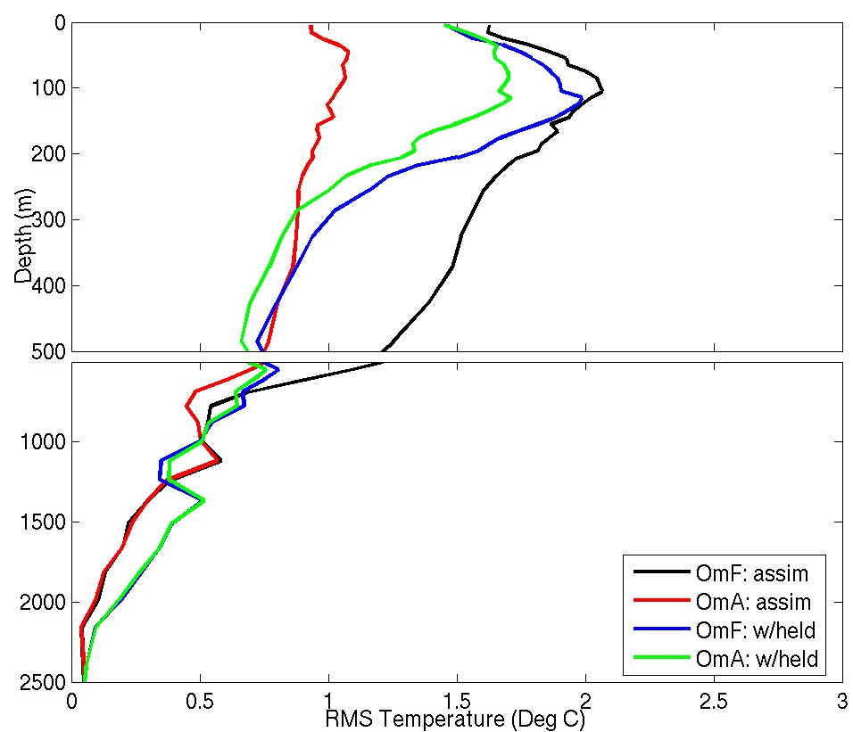
Figure 3: As for Figure 2, except restricted to the temperature profiles in the Tasman Sea (here defined as between the east coast of Australia and 170ºE; and between 20 and 40ºS).
A qualitative assessment of the ability of BRAN to represent the mesoscale variability in the Tasman Sea is presented in Figure 4. This figure show fields of 15-day averaged sea-level anomaly (SLA), with independent, observed drifter tracks overlaid. The time period depicted in Figures 4 corresponds to a period when several drifters were in the Tasman at the same time. The drifter data are not assimilated into BRAN and therefore provide independent evidence that BRAN provides a fairly realistic representation of the mesoscale variability in the Tasman Sea. We expect that geostrophic currents will flow along lines of constant pressure, here represented by contours of SLA. There are many instances in Figure 4 when this is clearly the case; for both the larger warm-core (anti-cyclonic) and smaller cold-core (cyclonic) eddies. There are also examples

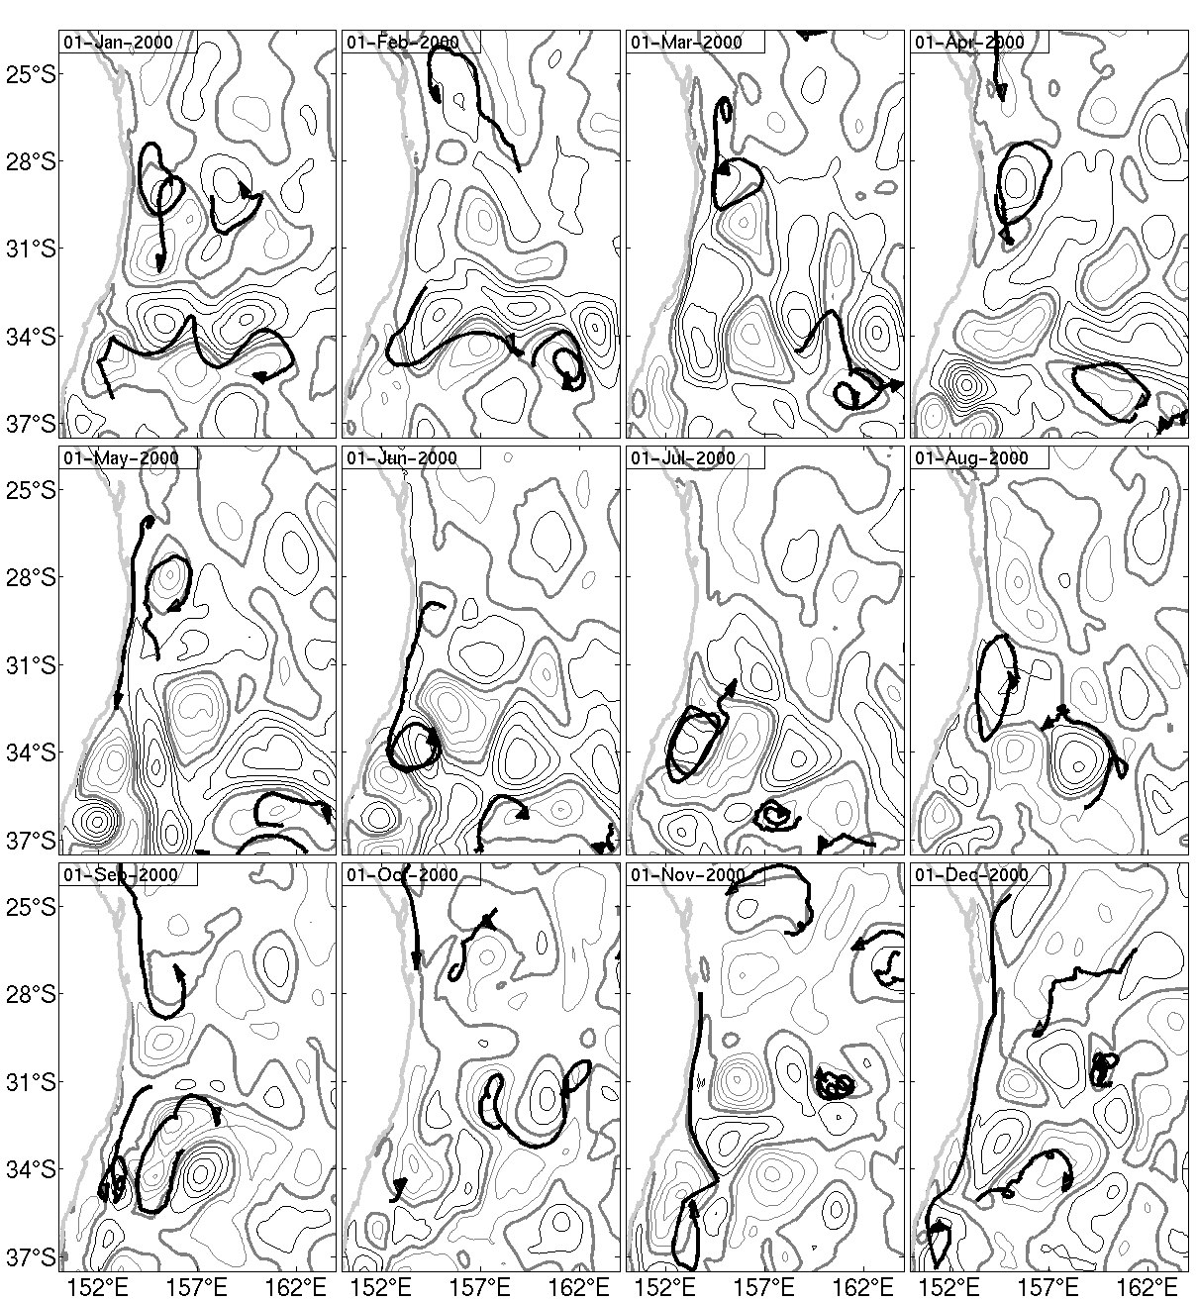
Figure 4: A sequence of reanalysed SLA (monthly means) from BRAN and surface drifters for the 1 month period centered at the specified date in 2000. The contour interval is 0.1 m s⁻¹; negative (cyclonic) anomalies are half tone; positive (anti-cyclonic) anomalies are solid contours; zero is bold and half tone. Adapted from Oke et al. (2005).

when the SLA fields in BRAN are not in good agreement with the drifter paths (e.g., November and December 2000); specifically when the true drifters appear to cross SLA contours. A quantitative comparison of BRAN currents with drifter currents and near-surface temperatures is presented by Oke et al. (2005). They show that there is statistically significant agreement between the reanalysed and withheld observations. By contrast, the equivalent SLA fields from the spin-up run (with no data assimilation) demonstrate no correspondence at all between the simulated eddy field and the drifter paths.
Another qualitative assessment of BRAN is presented in Figure 5, showing the reanalysed and observed SST and SLA fields in the Tasman Sea in early 2002. This figure compares 3-day composites of observed AVHRR SST fields and daily averaged SST from BRAN. Also contoured in Figure 5 are the reanalysed and “observed” SLA fields. The observed SLA fields are produced by optimally interpolating SLA from altimeters. Note that BRAN assimilates the same altimeter data that are used to produce the observed SLA fields and that BRAN SST is weakly restored to 12 composites of observed SST. We might therefore expect some artificial skill in the SLA fields, however, we suggest that any agreement between the observed and reanalysed SST for mesoscale events is evidence that BRAN has some skill for these scales of variability. In this example, the EAC, depicted by the warm SST off the coast of eastern Australia, is initially attached to the coast as far south as 35ºS on February 12 (Figure 5). On February 21, a branch of the EAC appears to begin to separate from the coast at about 33ºS. This leads to a warm filament of surface water protruding into the Tasman Sea on March 2. This sequence of events is well reproduced by BRAN and provides further evidence that BRAN is capable of reproducing mesoscale events in the Tasman Sea.
In addition to the results presented here, Oke et al. (2005) shows that BRAN compares favourably with observations of the NINO3.4 index and with sub-surface temperature at 100 m depth across the equatorial Pacific Ocean.
Both reanalysis and model-only fields are being made widely available and feedback from users is contributing to efforts to improve the quality of the system. An OPeNDAP server has been set up to provide registered users with access to all of the output from Bluelink modelling products http://www.cmar.csiro.au/ofam1/.
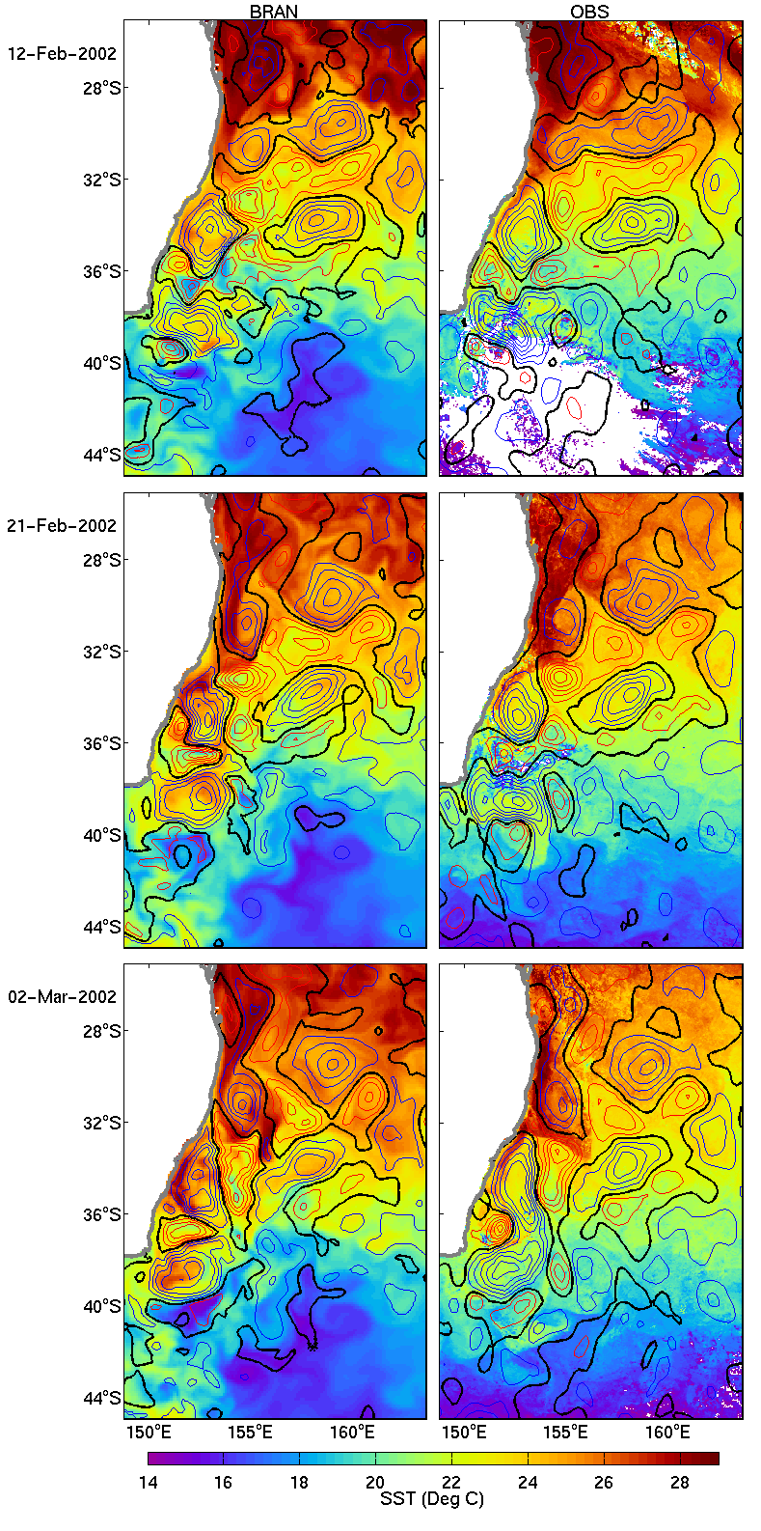
Figure 5: Re-analysed (left) and observed (right) SST (colour; 3-day composites for observed) and SLA (contour; contour interval is 0.1 m and blue (red) is negative (positive); OI-maps for observed).

5. Future plans
The next step in the Bluelink project is to modify this system for operational implementation at the Australian Bureau of Meteorology. The operational system will vary from BRAN in a number of important ways that may reduce the performance from what is demonstrated in this article. These variations include the use of near real-time observations which are reduced in both quantity and quality to delayed mode observations; the use of surface fluxes from operational atmospheric fore-casts rather than reanalyses; and the system configuration changes that are required to perform robustly. A significant effort towards this end is currently underway.
Acknowledgements:
This publication is a contribution to the Bluelink project that is funded by the Australian Bureau of Meteorology, CSIRO and the Royal Australian Navy. Funding from the US Office of Naval Research Ocean Modelling Program through Grant N000140410345 is also gratefully acknowledged. SST data were provided by NOAA and NASA/EOS; drifter data are provided by the DBDAC; and surface fluxes were provided by ECMWF.
References:
Chen, D., L. M. Rothstein, and A. J. Busalacchi: A hybrid vertical mixing scheme and its application to tropical ocean models. J. Phys. Oceanogr., 24, 2156-2179, 1994.
Evensen, G.: The Ensemble Kalman Filter: theoretical formulation and practical implementation. Ocean Dyn., 53, 343-367, 2003.
Gaspari, G. and S. E. Cohn: Construction of correlation functions in two and three dimensions. Quart. J. Roy. Meteor. Soc., 125, 723-757, 1999.
Griffies, S. M., M. J. Harrison, R. C. Pacanowski, and A. Rosati: A technical guide to MOM4. GFDL ocean group technical Report No. 5, pp 339. 2004.

Kallberg, P., A. Simmons, S. Uppala, and M. Fuentes: The ERA-40 archive. Reading, UK, European Centre for Medium-range Weather Forecasts (ECMWF), ECMWF Re-Analysis Project (ERA). ERA-40 Project Report Series, 17, 31p, 2004.
Levitus, S.: World Ocean Database. NOAA Professional Paper, 13, 2001.
Oke, P. R., J. S. Allen, R. N. Miller, G. D. Egbert, and P. M. Kosro: Assimilation of surface velocity data into a primitive equation coastal ocean model. J. Geophys. Res. Ocean., 107(C9), 3122, 2002.
Oke, P. R., A. Scihiller, D. A. Griffin, G. B. Brassington: Ensemble data assimilation for an eddy-resolving ocean model of the Australian region. Quart. J. Roy. Met. Soc., in press.
Reynolds., R. W., and T. M. Smith: Improved global sea surface temperature analyses using optimum interpolation, J. Climate, 7, 929-948, 1994.
Ridgway, K. R., J. R. Dunn and J. L. Wilkin: Ocean interpolation by four-dimensional weighted least squares- Application to the waters around Australasia. J. Atmos. and Oceanic Tech., 19, pp 1357-1375, 2002.
Schiller, A., G. B. Brassington, R. Fiedler, D. A. Griffin, J. Mansbridge, P. R. Oke, K. R. Ridgeway, and N. R. Smith: Eddy-resolving ocean circulation in the Asian-Australian region inferred from an ocean reanalysis effort. manuscript submitted to J. Geophys. Res. Ocean., 2005.

