Enhanced Ocean Prediction using Ensemble
Kalman Filter Techniques
P.I. Dr. Peter R. Oke ___________________________
CSIRO Marine Research
GPO Box 1538 Hobart TAS 7001 Australia
Castray Esplanade Hobart Tasmania
Telephone: +61 3 6232 5222
Facsimile: +61 3 6232 5000
peter.oke@csiro.au

Date of original submission: 18 July 2003
Date of resubmission: 8 December 2003
This proposal is submitted pursuant to the broad agency announcement 04-001, dated 09/10/03.
This transaction is subject to contract. In addition, the contract will require approval in accordance with the Science and Industry Research Act 1949. CSIRO will not be legally bound until these approvals are obtained.
Funding requested from ONR: | Year 1: $40,000 | Year 2: $45,900 | Year 3: $46,200
Funding requested from ONRIFO: | Year 1: $40,000 | Year 2: $45,900 | Year 3: $46,200
Funding provided by CMR: | Year 1: $22,210 | Year 2: $6,740 | Year 3: $15,400
Duration of effort: 01 January 2004 – 31 December 2006
Contracts Manager
Tim O’Sullivan:___________________________________
CSIRO Marine Research
GPO Box 1538
Hobart, TAS 7001, Australia
Email: tim.o’sullivan@csiro.au
Telephone: +61 3 6232 5223
Facsimile: +61 3 6232 5000

Business Manager
Tim Mangan:_____________________________________
CSIRO Marine Research
GPO Box 1538
Hobart, TAS 7001, Australia
Email: tim.mangan@csiro.au
Telephone: +61 3 6232 5267
Facsimile: +61 3 6232 5146
CSIRO is a non-profit institution.
Table of contents
Abstract 3
Response to ONR objectives 3
Scientific background 4
Proposed research and developments 5
Plan of action / Milestones timetable 7
Stage Plan 7
Cost Information 8
Intellectual Property Issues 9
Offerors’ Capabilities, related experience and facilities 9
References 10
Certifications 11

Abstract
The most critical aspects of a data assimilation system are the forecast error covariances (FECs). In practice, the FECs determine the weight and region of influence of an observation on an ensuing analysis. In reality, the FECs depend on geographic location, ocean state and the model’s ability to faithfully reproduce reality. However, in practice most applications rely on somewhat arbitrary estimates of the magnitude, length-scales and isotropy of the FECs. Such applications involve the employment of incorrect FECs and are consequently sub-optimal. The Ensemble Kalman Filter (EnKF) provides a practical solution to this problem, whereby the state-dependent FECs are determined from the statistics of an ensemble of forecasts. This ensemble is designed to span the probable future states of the ocean. The EnKF is an extremely powerful tool. As well as providing optimal analyses, it provides meaningful error estimates of both a forecast and analysis; it provides insight into the predictability of the circulation and it has the flexibility and portability of being able to be applied directly to non-linear models for a variety of different applications. The primary objective of this project is to develop an EnKF data assimilation system for application to eddy-resolving ocean circulation models. This system will be developed in collaboration with researchers from CSIRO, the Australian Bureau of Meteorology, Oregon State University and the Naval Research Laboratories.

Response to ONR objectives
The primary goal of this project is to develop of an advanced data assimilation system that will enhance the US Navy’s capability to make predictions of the mesoscale ocean circulation with skill on time scales of 4-10 days. This will enhance the US Navy’s military capabilities by providing improved fields for acoustic models that are routinely employed during naval exercises. At the completion of this project the data assimilation system will be delivered to researchers at the Naval Research Laboratories (NRL) for implementation at NAVOCEANO for the US Navy’s direct benefit.
This project is proposed under the Naval International Cooperative Opportunities in science and technology Program (NICOP) that is designed to encourage international collaboration in science and technology for the mutual benefit of the US Navy and international participants. The structure of this project is consistent with this design. Under an existing project that is being run in Australia, entitled Bluelink: Ocean Forecasting Australia, a forecast system for the mesoscale ocean circulation around Australia is being developed. This system combines a state-of-the-art ocean model (MOM4) with a multivariate optimal interpolation (MvOI) system that assimilates satellite-derived and in situ observations. The forecast system will be implemented operationally at the Australian Bureau of Meteorology (BoM) at the conclusion of the Bluelink project. Bluelink began in September 2002, was formally launched in Australia in October 2003 and is due to finish in July 2006. The Bluelink MvOI system is a simplified version of the data assimilation system that is proposed for development under this project. The research and development within this project will be undertaken through a new collaboration between Australian researchers and US researchers. As a result of this project Bluelink will benefit, as will the US researchers and the US Navy.

Statement of work

Scientific background
The EnKF, first described by Evensen (1994), is an optimal data assimilation technique that can be applied directly to non-linear models. As foreshadowed in the abstract, the most important components of any data assimilation system are the forecast error covariances (FECs). In practice, the FECs determine the weight and region of influence of an observation on an ensuing analysis. In reality, the FECs depend on geographic location, ocean state and the model’s ability to faithfully reproduce reality. However, in practice most applications rely on somewhat arbitrary estimates of the magnitude, length-scales and isotropy of the forecast errors (e.g., Daley 1991). Such applications involve the employment of incorrect FECs and are consequently sub-optimal. More critically, they produce analyses that are inconsistent with the dynamics of non-linear models (e.g., Williamson et al. 1981). A practical solution to this problem involves the application of an EnKF. This involves running an ensemble of parallel forecasts, each starting from a different initial state, where the initial spread of the ensemble is intended to reflect the uncertainty in these conditions. By assuming that the ensemble averaged prediction, or the ensemble member that is closest to it, is the best estimate of the truth, the forecast errors can be diagnosed as the deviations of each ensemble member from the ensemble average. With multiple estimates of the forecast errors available, the FECs can be calculated directly. These FECs form the basis of subsequent assimilations using MvOI. The result is an enhanced ocean prediction system with realistic FECs. The computational cost of running multiple forecasts can be very high, particularly for a global eddy-resolving configuration. Therefore, we propose to develop the EnKF system using a prototype model; a limited domain configuration of MOM4, with eddy-resolving resolution, realistic topography and realistic forcing. Importantly, this configuration will retain the major complexities of a realistic application (e.g., eddy resolving, variable topography, land barriers etc.), but will have a limited domain and will therefore run at a fraction of the computational cost of a global configuration. This feature will facilitate efficient method development. Subsequent implementation of this system to a realistic global, regional or coastal application should be straightforward, provided the computing resources are available.
There are many advantages to the EnKF compared to other methods of data assimilation that are applied to geophysical applications. For example, unlike variational techniques that require a tangent linear model and its adjoint to be developed in parallel the EnKF can be applied directly to non-linear models. This means that when the latest model becomes available, it should be possible for the EnKF system to be immediately applied to it, with minimal additional development effort. The EnKF is relatively easily adapted to different models and applications and is ideally suited to parallel computing environments. As the ensemble size increases, with additional processors, the error statistics improve leading to improved analyses. As a result, the performance of EnKF-based assimilation system improves with additional computing resources. The model-based, multivariate nature of this approach results in the optimal use of observations. This is particularly important in data-sparse regions. The EnKF also provides meaningful estimates of the errors in a given forecast and analysis. These error estimates could be adapted for use in acoustic modeling systems that the Navy may use for operational missions. Additionally, the EnKF provides insight into the predictability of ocean circulation under different conditions, providing the end-users of a forecast with an indication of the probability of a forecast being accurate.

Proposed research and developments
Because of the computational cost of running advanced data assimilation systems, applications to eddy-resolving ocean models have been very limited. Most applications have either combined advanced assimilation with a simple model (e.g., Kurapov et al. 2002), or simple assimilation with a complex model (e.g., Oke et al. 2002). Under this project, we propose to close the gap between these research applications and operation applications.
The EnKF is a natural extension of the MvOI system that is being developed under Bluelink. The Bluelink MvOI system has been designed with the framework of the EnKF in mind. It therefore represents a significant step towards the application of an EnKF to realistic eddy-resolving ocean models. Under Bluelink, model fields from a single multi-year integration are sub-sampled and converted into perturbation fields with the means, trends and seasonal cycles removed. The model perturbation fields are then treated as a stationary ensemble of model forecasts from which inhomogeneous, anisotropic, multivariate estimates of the FECs can be derived. This approach translates to an assumption that the FECs are proportional to the typical covariances between modeled variables. Preliminary results from observing system simulation experiments (OSSEs) using the Bluelink MvOI system are encouraging (Figure 1). This approach is similar to the method developed by Oke et al. (2002).
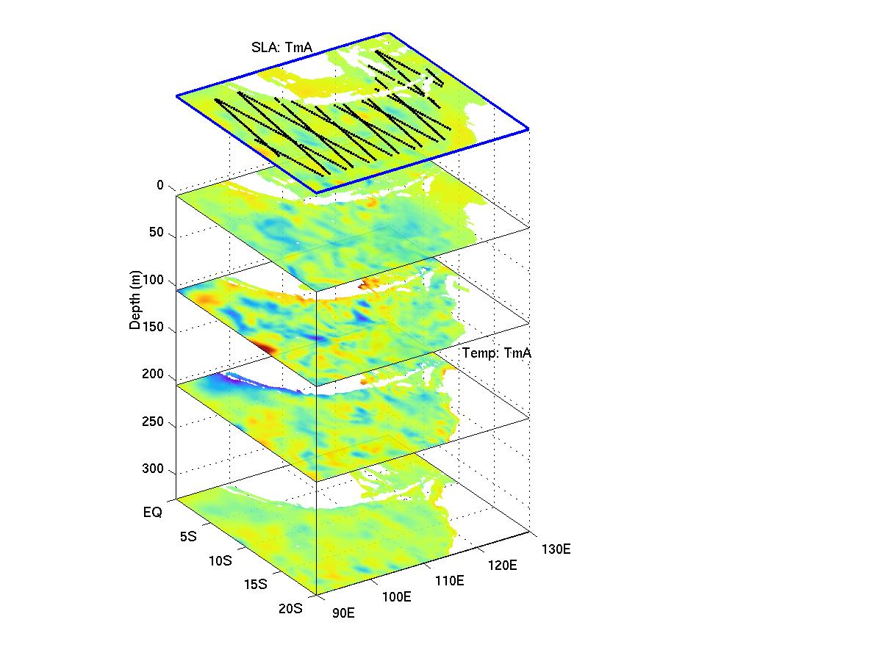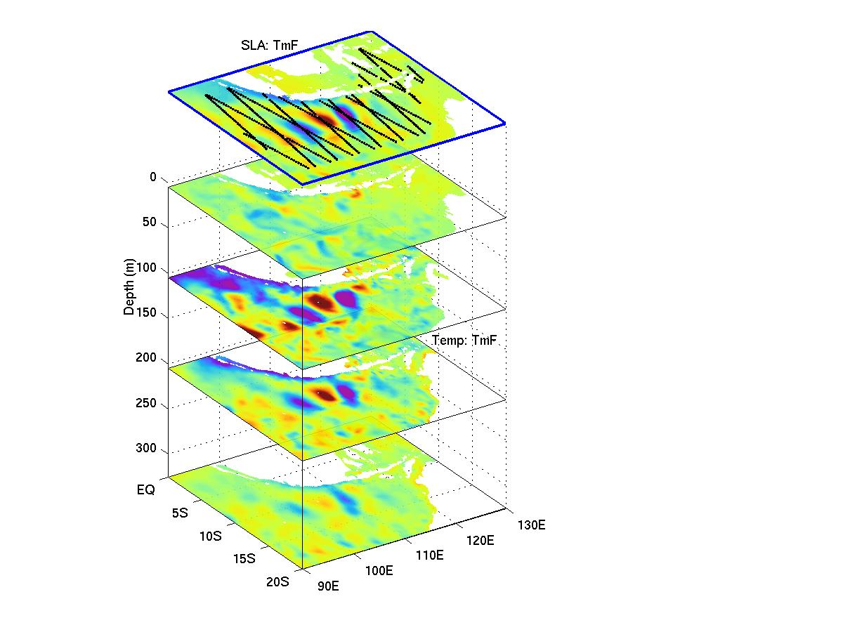 Figure 1. Preliminary results from an OSSE using the Bluelink MvOI system, showing the three-dimensional impact of assimilation of sea-level anomalies (SLA) for the region between NW Australia and Indonesia. For this example, simulated observations of SLA are sampled from a “truth” run along the altimeter tracks denoted in the top panels, and noise is added to these observations. An “analysis” is then produced by combining the simulated observations with a “forecast” using MvOI. The top panels also show the truth-minus-forecast (TmF; left) and the truth-minus-analysis (TmA; right) for SLA. The underlying panels show TmF (left) and TmA (right) for temperature at 5, 105, 205 and 325 m depth. For this example, TmF is the forecast error; and TmA is the analysis error after the simulated observations are assimilated.
The reduction in the error from the forecast to the analysis demonstrates the effectiveness of the assimilation system. In addition to the many technically challenges involved in the extension of the Bluelink MvOI system into an EnKF, there are also a number of research issues that include:
- How should the initial conditions for each ensemble member be generated so that they reflect the true uncertainty in the initial conditions?
- How should the model error (as distinct from the forecast error) be estimated?
- What size ensemble is sufficient?
- Do the FECs converge to a stationary, or seasonally varying, state?
- Do the FECs provide any insights into the sources of forecast and model errors?

Plan of action / Milestones timetable
In the first year of this project, an eddy-resolving, limited domain prototype model will be developed and configured for a series of OSSEs. The Bluelink MvOI system will then be applied to this model and its performance will be assessed.
In the second year of this project the Bluelink MvOI system will be extended into a full EnKF. This will involve the development of a system that objectively generates the initial conditions for ensemble members. Various methods have been proposed for this aspect of the EnKF. Evensen (1994) suggests the use of the ensemble-based analysis error covariances, however this can lead to a degenerative ensemble (van Leeuwen 1999; Houtekamer and Mitchell 1998; 1999). Subsequently, Evensen (2003) suggested the use of spatially correlated noise for this initialization. Finally, the notion of perturbing observations to initialize ensemble members was introduced for numerical weather prediction applications by Houtekamer and Mitchell (1998) and was theoretically justified by Burgers et al. (1998). A series of OSSEs will be performed in year 2 to test the performance of the EnKF.
In year three of this project a detailed comparison between the Bluelink MvOI system and the EnKF system will be undertaken. The final configuration of the EnKF system will be established and delivered to NRL along with the necessary documentation, code, scripts etc.
In each year of the project the collaboration between the Australian and US researchers involved in this project will be substantiated through face-to-face meetings to discuss the research and development issues. The tasks outlined above will be undertaken by a PostDoc, who will be supported under this project. However the synergies between this project and the Bluelink project are so strong that many tasks are closely related and overlapping. The investigators involved in Bluelink (Oke, Alves and Schiller) are therefore likely to contribute directly to these tasks during the course of the project.

Stage Plan
Year 1 | - Configure the prototype model; a limited domain ocean circulation model with eddy-resolving resolution, realistic topography and realistic forcing.  - Perform a series of model runs to enable the Monte-Carlo-based multivariate covariances to be calculated for implementation with the Bluelink MvOI system.  - Implement the Bluelink MvOI system for the prototype model.  - Perform a series of OSSEs to assess the performance of the Bluelink MvOI system in the prototype model.  - CMR representative to visit SSC/NRL and OSU to establish collaboration and exchange assimilation code.

Year 2 | - Develop a system to routinely generate the initial conditions for ensemble members.  - Develop a method for estimating the model error covariances in the EnKF algorithm.  - Convert the Bluelink MvOI system into a full EnKF system and undertake preliminary tests of the EnKF system on the prototype model.  - Prepare a draft version of the documentation of the EnKF system.  - Either CMR representative to visit SSC/NRL and OSU, or US investigators to visit CSIRO to continue collaboration.
Year 3 | - Compare the performance of the EnKF system and the Bluelink MvOI system when applied to the prototype model.  - Prepare final documentation of the EnKF system and deliver to NRL.  - CMR representative to visit SSC/NRL to deliver the final version of the EnKF system.
At the completion of this project, all the necessary source code, run scripts and documentation for the EnKF system will be provided to NRL.
Annual reports, documenting the progress of this project will be submitted to ONR every year.
Cost Information
Funding is requested to support a Post Doctoral Research Associate for three years. The research will be undertaken by the Post Doc under the supervision of the principal investigators listed above. Approximately 85% of the funding for the Post Doc is requested from ONR. In addition to this, both CSIRO and BoM have invested a substantial amount of resources in Bluelink, as noted above. The costs that contribute to the salary for the Post Doc each year; equipment costs for computer hardware and facilities costs for computing and network costs are tabulated below in US$. The proposed contributions from ONRIFO, ONR and CMR are also tabulated. Overheads of 60% are included in the tabulated costs to cover divisional support and infrastructure. All of the Australia-based investigators that are to be involved in this project (Oke, Alves and Schiller) receive financial support under Bluelink.
 | Total | FY04 | FY05 | FY06
Staff | $247.59 K | $76.45 K | $81.98 K | $89.16 K
Travel | $16.80 K | $5.60 K | $5.60 K | $5.60 K
Facilities | $34.72 K | $12.32 K | $8.96 K | $13.44 K
Equipment | $7.84 K | $7.84 K | $0.00 K | $0.00 K
Total | $306.95 K | $102.21 K | $96.54 K | $108.20 K
ONR contribution | $131.30 K | $40.00 K | $44.90 K | $46.40 K
ONRIFO contribution | $131.30 K | $40.00 K | $44.90 K | $46.40 K
CMR contribution | $44.35 K | $22.21 K | $6.74 K | $15.40 K

Intellectual Property Issues
CSIRO and BoM request that ONR to acknowledge that CSIRO and BoM may carry out research within the field of data assimilation using some form of the EnKF system developed under this project independently or with third parties provided it does not breach its confidentiality obligations to ONR.
CSIRO and BoM request ONR to acknowledge that the data assimilation system developed under this project may be implemented operationally in Australia and subsequently utilized by the RAN for military purposes.

Offerors’ Capabilities, related experience and facilities
The contact details of the Australia-based investigators are:
Dr. Peter Oke  CSIRO Marine Research  GPO Box 1538  Hobart, TAS 7001, Australia  Email: peter.oke@csiro.au  Tel: +61 3 6232 5387  Fax: +61 3 6232 5123 | Dr. Oscar Alves  Ocean and Marine Forecasting Group  Bureau of Meteorology Research Centre  GPO Box 1289K  Melbourne, VIC 3001, Australia  Email: o.alves@BoM.gov.au  Tel: +61 3 9669 4835  Fax: +61 3 9669 4660
Dr. Andreas Schiller
CSIRO Marine Research
GPO Box 1538
Hobart, TAS 7001, Australia
Email: andreas.schiller@csiro.au
Tel: +61 3 6232 5300
Fax: +61 3 6232 5123

The contact details for the US-based researchers are:
Dr. Gregg Jacobs  Naval Research Laboratory  Stennis Space Center  Mississippi, 39529, USA  Email: gregg.jacobs@nrlssc.navy.mil  Tel: +1 228 688 4720  Fax: +1 228 688 4759 | Prof. Robert N. Miller  College of Oceanic and Atmospheric Sciences  Oregon State University  104 Ocean Admin. Bldg  Corvallis, OR 97331-5503, USA  Email: miller@coas.oregonstate.edu  Tel: +1 541 737 4555  Fax: +1 541 737 2064
The principal investigator, Dr. P. R. Oke has been involved in the research and development of ocean data assimilation systems since 1998 for a variety of different applications ranging from coastal (under an ONR-funded NOPP project at Oregon State University) to global forecast systems (under Bluelink). The other Australia-based investigators (Dr. O. Alves and Dr. A. Schiller) have been involved in research and development of ocean data assimilation systems (e.g., Alves et al. 2001; Schiller and Willebrand 1995) and have been involved in the development and implementation of operational forecast systems at BoM (e.g., Zhong et al. 2001). Both of the US-based investigators are actively researching advanced data assimilation methods. Dr. R. N. Miller’s has a long history of research involving Kalman Filtering (e.g., Miller 1989). His group at Oregon State University is investigating methods of ensemble generation for non-linear models. Dr. G. Jacob’s group is developing and comparing several advanced assimilation techniques ranging from 4D-VAR, using adjoint and representer methods, to EnKF-based approaches.
The primary computing facility utilized by CMR and BoM is the High Performance Computing and Communication Center (HPCCC) located in Melbourne Australia. The main computer at the HPCCC is an NEC SX5 machine with 32 8Gflop/s vector processors. In early 2004, an NEC SX6 is being installed that has 228 8Gflop/s vector processors. We also have access to the Australian and Tasmanian Partnership for Advanced Computing (APAC and TPAC) that have over 500 0.5-1 GHz processors. These facilities provide an excellent computing environment for the development of algorithms that can take advantage of parallel processing.

References
Alves, J. O. S., Haines, K., Anderson, D. L. T. 2001: Sea Level Assimilation Experiments in the Tropical Pacific. Journal of Physical Oceanography, 31, 305–323.
Burgers, G., P. J. van Leeuwen, and G. Evensen, 1998: Analysis scheme in the ensemble Kalman filter. Monthly Weather Review, 126, 1719-1724.
Daley, R., 1991: Atmospheric Data Assimilation. Cambridge University Press, 457 pp.
Evensen, G., 1994: Sequential data assimilation with a nonlinear quasigeostrophic model using Monte Carlo methods to forecast error statistics. Journal of Geophysical Research, 99 (C5), 10143-10162.
Evensen, G., 2003: The Ensemble Kalman Filter: Theoretical Formulation and Practical Implementation. Ocean Dynamics, 53, 343-367, 2003.
Houtekamer, P. L., and H. L. Mitchell, 1998: Data assimilation using an ensemble Kalmen filter technique. Monthly Weather Review, 126, 2776-2790.
Houtekamer, P. L., and H. L. Mitchell, 1999: Reply. Monthly Weather Review, 127, 1378-1379.
Kurapov, A. L., G. D. Egbert, R. N. Miller, and J. S. Allen, 2002: Data Assimilation in a baroclinic coastal ocean model: Ensemble statistics and comparison of methods. Monthly Weather Review. 130, 1009-1025.
Miller, R. N., 1989: Direct assimilation of altimetric differences using the Kalman filter. Dynamics of Atmospheres and Oceans, 13, 317-333.
Oke, P. R., J. S. Allen, R. N. Miller, G. D. Egbert and P. M. Kosro, 2002: Assimilation of surface velocity data into a primitive equation coastal ocean model. Journal of Geophysical Research, 107 (C9) 3122, doi:10.1029/2000JC000511.
Schiller, A., J. Willebrand, 1995: A technique for the determination of surface heat and freshwater fluxes from hydrographic observations, using an approximate adjoint ocean circulation model. Journal of Marine Systems, 53, 433-451.
van Leeuwen, P. J., 1999: Comment on “Data assimilation using an ensemble Kalman filter technique.” Monthly Weather Review, 127, 1374-1377.
Williamson, D. L., R. Daley, T. W. Schlatter, 1981: The Balance between Mass and Wind Fields Resulting from Multivariate Optimal Interpolation. Monthly Weather Review, 109, 2357-2376.
Zhong, A., O. Alves, A. Schiller, G. Wang, F. Tseitkin and N. Smith, 2001. A new version of the BMRC coupled ocean-atmosphere general circulation model for seasonal predictions: a brief description. BMRC Research Report.

Certifications
By signing and submitting the proposal, the proposer is providing the: (1) Certification at Appendix A to 32 CFR Part 25 regarding debarment, suspension, and other responsibility matters; (2) Certification at Appendix C to 32 CFR Part 25 regarding drug-free workplace requirements; and (3) Certification at Appendix A to 32 CFR Part 28 regarding lobbying.

